2019

HOLDING
COMPANY
BUSINESS PLAN

[Tri Holdings Inc. ]
[Business Plan For Fiscal Year 2019]
[June 25, 2019]

[Charlie Bland]
[charliebland@gmail.com]
[910-577-8925]
[wwwcharliebland.com]
[1858 Mesa Drive
Las Vegas, Nevada 89101, USA]

Index

Executive Summary | [PAGE NUMBER]
Company Overview | [PAGE NUMBER]
Products and Services | [PAGE NUMBER]
Execution | [PAGE NUMBER]
Operational Plan | [PAGE NUMBER]
Financial Plan | [PAGE NUMBER]

EXECUTIVE SUMMARY

[Tri Holdings Inc.] is a holding company which invests in real estate-related businesses. It is a parent corporation to three subsidiaries: first is the real estate company, [Hurricane Inc.], second is the construction company, [Red Corp.], and lastly, the rental company, [Happystones Inc.]

The company will be utilizing its automated marketing system and social media for its marketing strategies. It also aims to invest in a fourth subsidiary company and has started this goal by making a list of real estate-related businesses in the state of Nevada whose stocks are open for acquisition.

COMPANY OVERVIEW

Mission Statement

The mission of [Tri Holdings Inc.] is to invest in real estate, construction, and rental businesses that bring real benefits to the state of Nevada and its people.

Philosophy

[Tri Holdings Inc.] will always focus on the people. It strives for the empowerment of the people, pursuit of excellence, enhancement of the quality of life, and responsibility to the community. The company, being centered on this philosophy, will work as an effective member of the industry.

Vision

[Tri Holdings Inc.] is the leading property development company in the state of Nevada. Through its investments, the company aims to deliver exceptional shareholder value, cultivate progress in remote areas, and integrate sustainable development with superior business results.

Outlook

The state of Nevada is listed as one of the ten states predicted to have a strong real estate market in [2018]. The company plans to contribute to strengthening the market by investing in real estate-related businesses. Investing in these businesses would result in the continued growth of the industry and, in turn, would result in the increase of company sales and market share.

Type of Industry

- Real Estate
- Construction
- Rental

Business Structure: Corporation

Ownership: Corporation

Voting Shares | Non-voting Shares
Jan Presley | Danielle Talbot
Brian Aikens | Jennifer Cooksey
Clair Baehr | Amy Perez
Kendall Hicks | Jean Forrest
Joseph Williams
Betty Kirk

Subsidiaries:

[Hurricane Inc.] (Real Estate Company) [100]% ownership
[Red Corp.] (Construction Company) [58]% ownership
[Happystones Inc.] (Rental Company) [55]% ownership

Start-Up Summary

The start-up cost is $[2M] USD to be provided by the shareholders from their shares in the company before the incorporation. The start-up cost will be used for acquisitions, legal fees, insurance, research and development, and payroll.

Start-Up Funding
Start-Up Expenses to Fund | $1,500,000.00
Start-Up Assets to Fund | $500,000.00
Total Funding Required | $2,000,000.00
Assets
Non-Cash Assets from Start-Up | $100,000.00
Cash Requirements from Start-up | $50,000.00
Additional Cash Raised | $50,000.00
Cash Balance on Starting Date | $300,000.00
Total Assets | $500,000.00
Capital
Planned Investment
Shareholders (Common shares) | $1,500,000.00
Shareholders (Preferred shares) | $500,000.00
Additional Investment Requirement
Total Planned Investment | $2,000,000.00
Loss at Start-Up (Start-Up Expenses) | -$1,500,000.00
Total Capital | $500,000.00
Total Capital and Liabilities | $500,000.00
Total Funding | $500,000.00
Start-Up
Requirements
Land and Building | $500,000.00
Advertising | $10,000.00
Legal Fees | $80,000.00
Insurance | $100,000.00
Construction and Design | $300,000.00
Research and Development | $10,000.00
Others | $500,000.00
Total Start-Up Expenses | $1,500,000.00
Start-Up Assets
Cash Required | $400,000.00
Start-Up Inventory | $50,000.00
Other Current Assets | $25,000.00
Long-Term Assets | $25,000.00
Total Assets | $500,000.00
Total Requirements (Total Start-Up Expenses + Total Assets) | $2,000,000.00

Management Team

Management Team | Role/Function | Skills
Danielle Talbot | Chief Executive Officer | Collaboration, decision-making, and time management skills
Jennifer Cooksey | Chief Financial Officer | Financial accounting, and corporate finance, and leadership skills
Amy Perez | Administrative Officer | Communication, customer service, and research skills

Short- and Long-Term Goals and Milestones

Short-Term Goals | Milestones
Own more than [70]% of the shares in the subsidiary companies | The shareholders have already acquired full ownership of [Hurricane Inc.], [58]% ownership of [Red Corp.], and [55]% ownership of [Happystones Inc.]
Establish a council of company presidents | The company has already scheduled a meeting with the Board of Directors of each company with the following schedules:  [Hurricane Inc.] – [March 1, 2019]  [Red Corp.] – [March 15, 2019]  [Happystones Inc]. – [March 31, 2019]
Long-Term Goals | Milestones
Increase the available capital stock of the company from [40,000] shares to [100,000] shares in [15] years | The company is already preparing a plan to open its stocks to the public [7] years after the start of the business operations.
Invest in a fourth subsidiary company | The company has given a directive to make a list of real estate-related businesses whose stocks are open for acquisition.

PRODUCTS AND SERVICES

Product/Service Description

[Tri Holdings Inc.] being a holding company, does not have any operations or active business itself. It instead owns assets in the three subsidiary companies. The business of the three subsidiary companies is all real-estate related businesses. [Hurricane Inc.] is a real estate company engaging in the business of buying and selling real estate properties. Red Corp. is a construction company that is in the business of constructing real estate properties. Lastly, [Happystones Inc.] is a rental company which rents commercial spaces. All companies are operated in the state of [Nevada].

Value Proposition

Providing opportunities to clients for a better life. [Tri Holdings Inc.] invests in real estate-related businesses and its successful investment in growing companies is known to help the businesses improve their operations as well as the products and services they provide to their customers.

Pricing Strategy

As the company is a parent company and does not have its own operations, the pricing strategy covers the pricing strategy of its subsidiary companies. [Hurricane Inc.] utilizes competitive pricing. [Red Corp.] utilizes price bundling and competitive pricing. Lastly, [Happystones Inc.] uses the price skimming strategy.

EXECUTION

Marketing Plan

[Tri Holdings Inc.] aims to invest in more real estate-related businesses outside the state of [Nevada]. As a holding company, it gains profit by synergy and profit from the associated subsidiaries. The company’s marketing plan mainly focuses on which companies it holds and how to manage them.

Market Research

The current trend in the real estate industry implies that there is more growth in the residential real estate sector. Its market share in the real estate industry has also increased.

The chart below shows the real estate business market share by sector where the company has made its investments.
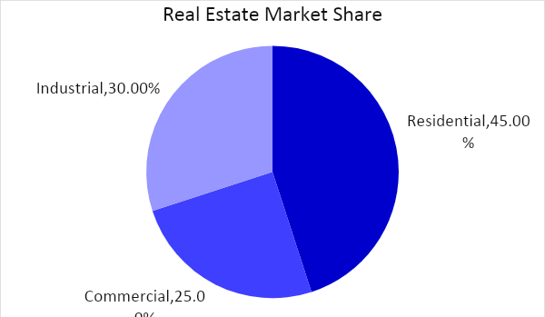

SWOT Analysis | Strengths | Weaknesses | Opportunities | Threats
[Tri Holdings Inc.] | - Has a strong presence in Nevada  - Has managerial independence to develop the business with three subsidiaries | - The company has limited operations. | - High demand for all real estate sectors, hence large opportunities to tap the market | - Destruction of real estate properties due to natural disaster
[Holdingsize] | - Has innovative construction solutions  - Has a diversified portfolio in real estate | - Only present on the western side of the US  - Quality control issues in construction | - Opportunities in developing nations  - Expansion in emerging markets | - Fluctuating land price
[Beholdings] | - Has employed more than 500 employees  - Has operations in more than 5 states in the US | - The company has limited operations across the US | - Can increase geographical reach in the US | - Changes in regulation and taxation

Marketing Strategy

[Tri Holdings Inc.] plans on utilizing an ongoing automated marketing system to contact potential clients, utilize social media, and invest in more real estate-related businesses. The company currently has an automated marketing system but needs to be updated. On the other hand, the company has started to create social media accounts. Lastly, the company has given a directive to make a list of real estate-related businesses whose stocks are open for acquisition.

The team has kicked-off various activities to move the marketing strategy forward. Here are some of the updates:

Marketing Strategy | Activities | Timeline | Success Criteria
Utilize an ongoing automated marketing system | The marketing department hired a new IT manager. | February 1, 2019 | The new IT manager will update the automated marketing system by the end of February 2019.
Utilize social media | The marketing department has started creating the following social media accounts: Facebook, Instagram, YouTube, and LinkedIn | March 31, 2019 | All the social media accounts are operational before the end of April 2019.

Organizational Structure

Shareholders
Board of Directors
President
CEO
CFO
Chairman, BOD
General Affairs Dept.
Finance Department
Marketing Department
HR Department
Council of Company Presidents
Hurricane Inc.
Red Corp.
Happystones Inc.

OPERATIONAL PLAN

Location and Facilities

The corporate office of the company is located in the [Tri Holdings Inc.] [Bldg. 1858 Mesa Drive, Las Vegas, Nevada]. The 5-story building houses all its employees and the offices for all its subsidiary companies.

Tools and Equipment Checklist

The company, being a holding company, does not have its own tools and equipment since it does not have its own operations. The company has only acquired computer sets for its employees.

Software | Quantity
Intercom | 1
Boomtown | 1
Hardware | Quantity
Computer | 50

IT Infrastructure

The following table reflects [Tri Holdings Inc.] IT infrastructure.

Infrastructure | Existing (Y/N) | Description
Social Media | Y | The company has Facebook, Instagram, YouTube, and LinkedIn.

FINANCIAL PLAN

Assumptions

The financial forecast is based mainly on the current trends in the real estate industry. The company will focus much of its efforts to increase the profits of the subsidiary companies.

Monthly Expense

The chart shows the projected monthly expense for [2019]. As the company’s fiscal year starts on [July 2019], the expenses provided below starts in [July].
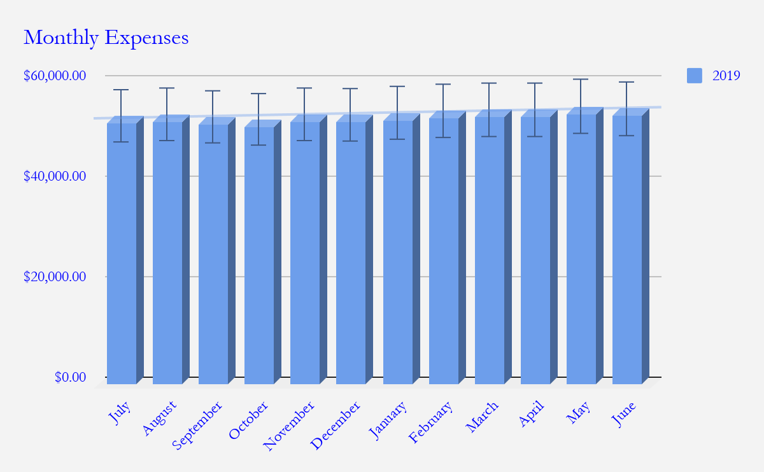

Monthly Revenue

This chart depicts the projected monthly revenue for [2019]. As the company’s fiscal year starts on [July 2019], the revenues provided below starts in [July].

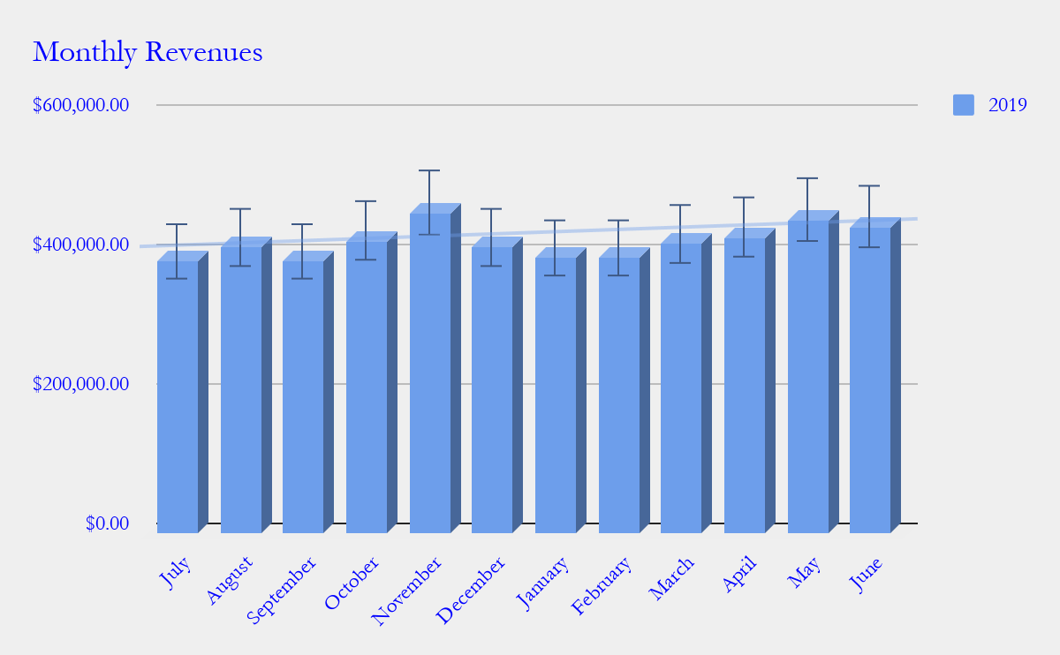

Business Financing

The funding for the business mainly comes from the investment of the shareholders. The shareholders with common shares each contribute $[250,000.00] and the shareholders with preferred shares each contribute $[125,000.00], which all amount to $[2,000,000.00].

Statements

Profit and Loss Projection
 | FY2019 | FY2020 | FY2021
Sales | $5,000,000.00 | $7,000,000.00 | $10,000,000.00
Direct Cost of Sale | $1,200,000.00 | $1,400,000.00 | $1,700,000.00
Other Cost of Sale | $500,000.00 | $700,000.00 | $800,000.00
Total Cost of Goods Sold or COGS (Sales - Direct Cost of Sale - Other Cost of Sale) | $3,300,000.00 | $4,900,000.00 | $7,500,000.00
Gross Profit (Sales-Total Cost of Goods Sold) | $1,700,000.00 | $2,100,000.00 | $2,500,000.00
Gross Margin % (Gross Profit/Sales) | 34.00% | 30.00% | 25.00%
Operating Expenses
Training Expense | $20,000.00 | $50,000.00 | $75,000.00
Insurance | $500,000.00 | $500,000.00 | $500,000.00
Utilities | $1,200.00 | $1,440.00 | $1,800.00
Salaries Expense | $100,000.00 | $120,000.00 | $140,000.00
Other Expenses | $10,000.00 | $10,500.00 | $11,000.00
Total Operating Expenses | $631,200.00 | $681,940.00 | $727,800.00
EBITDA (Total Cost of Sale-Total Operating Expenses) | $2,668,800.00 | $4,218,060.00 | $6,772,200.00
Depreciation | $50,000.00 | $50,000.00 | $50,000.00
Interest Expense | $300,000.00 | $500,000.00 | $700,000.00
Taxes Paid | $120,000.00 | $200,000.00 | $250,000.00
Net Profit (Gross Profit - Operating Expenses - Taxes - Interest) | $648,800.00 | $718,060.00 | $822,200.00

Balance Sheet Projection
 | FY2019 | FY2020 | FY2021
Cash | $400,000.00 | $400,000.00 | $400,000.00
Accounts Receivable | $1,250,000.00 | $1,750,000.00 | $2,500,000.00
Total Current Assets | $1,650,000.00 | $2,150,000.00 | $2,900,000.00
Long-Term Assets | $1,000,000.00 | $1,000,000.00 | $1,000,000.00
Accumulated Depreciation | $50,000.00 | $100,000.00 | $150,000.00
Total Long-Term Assets (Long-Term Assets-Accumulated Depreciation) | $950,000.00 | $900,000.00 | $850,000.00
Total Assets (Total Current Assets + Total Long-Term Assets) | $2,600,000.00 | $3,050,000.00 | $3,750,000.00
Accounts Payable | $1,000,000.00 | $1,200,000.00 | $1,500,000.00
Notes Payable | $50,000.00 | $60,000.00 | $70,000.00
Other | $10,000.00 | $15,000.00 | $20,000.00
Total Liabilities | $1,060,000.00 | $1,275,000.00 | $1,590,000.00
Paid-in Capital | $800,000.00 | $1,000,000.00 | $1,160,000.00
Retained Earnings | $740,000.00 | $775,000.00 | $1,000,000.00
Total Owner's Equity (Total Assets - Total Liabilities) | $1,540,000.00 | $1,775,000.00 | $2,160,000.00
Total Liabilities & Equity (Total Liabilities/Total Owner's Equity) | 68.83% | 71.83% | 73.61%

Cash Flow Projection
 | FY2019 | FY2020 | FY2021
Operating Cash Beginning | $400,000.00 | $400,000.00 | $400,000.00
Sources of Cash | $50,000.00 | $50,000.00 | $50,000.00
Receivables | $1,250,000.00 | $1,750,000.00 | $2,500,000.00
Sales | $5,000,000.00 | $7,000,000.00 | $10,000,000.00
Others | $0.00 | $0.00 | $0.00
Total Cash | $6,700,000.00 | $9,200,000.00 | $12,950,000.00
Expenditures
Training Expense | $20,000.00 | $50,000.00 | $75,000.00
Insurance | $500,000.00 | $500,000.00 | $500,000.00
Utilities | $1,200.00 | $1,440.00 | $1,800.00
Salaries Expense | $100,000.00 | $120,000.00 | $140,000.00
Other Expenses | $10,000.00 | $10,500.00 | $11,000.00
Total Expenditures | $631,200.00 | $681,940.00 | $727,800.00
Net Income/Loss (Total Cash - Total Expenditures) | $6,068,800.00 | $8,518,060.00 | $12,222,200.00

