COSMETIC BUSINESS PLAN

[INSERT NAME OF THE BUSINESS/COMPANY]
[INSERT THE COMPLETE BUSINESS/COMPANY ADDRESS]
[INSERT THE BUSINESS/COMPANY CONTACT NUMBERS]
[INSERT THE BUSINESS/COMPANY EMAIL ADDRESS]
[INSERT THE BUSINESS/COMPANY WEBSITE ADDRESS]

PREPARED BY:

[INSERT FULL NAME/S OF THE
PEOPLE WHO PREPARED THIS PLAN]

[INSERT DATE]

Index

Executive Summary [PAGE NUMBER]
Company Overview [PAGE NUMBER]
Products and Services [PAGE NUMBER]
Execution [PAGE NUMBER]
Operational Plan [PAGE NUMBER]
Financial Plan [PAGE NUMBER]

Executive Summary:

[Nzuri Cosmetics] is a cosmetic brand that focuses on color cosmetics such as [eye palettes, blush, highlighters, bronzers, and lipsticks]. The company is seeking recurring investments from stores such as Sephora, Ulta, and other department stores to fund the growth of the brand. The following business plan will show how the brand will reach profitability within three years of operation.

Company Overview:

Mission Statement: It is the mission of [Nzuri Cosmetics] to represent quality cosmetics by manufacturing high-quality products for a comprehensive distribution network using retail outlets and Internet presence.

Philosophy: [Nzuri Cosmetics] prides itself for using only the best ingredients while keeping consumer costs low.

Vision: [Nzuri Cosmetics] sees itself as a leading cruelty-free and vegan cosmetic brand that won’t break the bank.

Outlook: The beauty industry has grown significantly over the [past few years]. Younger consumers, in particular, are rejecting large brands in preference of locally-made, [cruelty-free products], and creative packaging.

Type of Industry: Beauty and Cosmetics

Business Structure: Sole Proprietorship

Ownership: Sole Proprietorship, [Dianne Taylor]

Start-Up Summary: The start-up cost is [USD 450,000], which shall be provided by the owner and shall be used for rent, supplies, payroll, and maintenance.

Start-Up Funding
Start-Up Expenses | $100,000
Start-Up Assets | $350,000
Total Funding Required | $450,000
Assets
Non-Cash Assets from Start-Up | $20,000
Cash Requirements from Start-up | $30,000
Additional Cash Raised | $50,000
Cash Balance on Starting Date | $250,000
Total Assets | $350,000
Capital
Planned Investment
Owner | $350,000
Other | $0
Additional Investment Requirement | $0
Total Planned Investment | $350,000
Loss at Start-Up (Start-Up Expenses) | $100,000
Total Capital | $450,000
Liabilities | $0
Total Capital and Liabilities | $450,000
Start-Up
Requirements
Start-Up Expenses
Rent - 5 Months | $30,000
Advertising | $10,000
Legal Fees | $10,000
Staff Training | $30,000
Insurance | $20,000
Other | $0
Total Start-Up Expenses | $100,000
Start-Up Assets
Cash Required | $330,000
Start-Up Inventory | $5,000
Other Current Assets | $5,000
Long-Term Assets | $10,000
Total Assets | $350,000
Total Requirements (Total Start-Up Expenses + Total Assets) | $450,000

Management Team:

Management Team | Role/Function | Skills
Debbie Betton | Operations Manager | Communications, People Management, Teamwork
Cynthia Cooper | Sales and Marketing | Communications, Sales, Performance Management

Short- and Long-Term Goals and Milestones:

Short-Term Goals | Milestones
- Hire front-end developer for brand website | - Developer hired, website in progress
- Hire a creative team to develop labels and logo | - Development of creative labels in progress
Long-Term Goals | Milestones
- Hire chemists to develop different cosmetic formulas | - Hired three of five necessary chemists
- Look for commercial space for a physical store | - Currently looking into properties

Products and Services

Product/Service Description: [Nzuri Cosmetics] manufactures and distributes color treatment cosmetics, focusing on makeup such as [eye palettes, highlighters, blush, lipsticks, lip glosses, and tints].

Value Proposition: [Nzuri Cosmetics] has extensive cosmetic products that allow differing consumer tastes and preferences, whether consumers are looking for a [simple, neutral makeup or something for dramatic party looks], [Nzuri Cosmetics] will stir up excitement that will give its customers the perfect excuse to stop by at the store.

Pricing Strategy: [Nzuri Cosmetics] utilizes mark-up, competitive pricing strategies that are typical of retail brands.
Execution

Marketing Plan: [Nzuri cosmetics] will utilize a brand-building strategy that positions its print advertisements in magazines that influence our target markets such as Cosmopolitan, Vogue, Vanity Fair, and The New York Times Lifestyle edition. In addition, it will also retain a PR firm that will help develop a grassroots program for obtaining product placement and celebrity endorsements.

Market Research: Younger consumers of cosmetic products are looking for more holistic, cruelty-free brands. Although the dynamics of the beauty industry have favored large houses such as [L’Oreal] and [Clinique,] brands such as [The Body Shop] and [Urban Decay] brought awareness regarding cruelty-free and vegan beauty products with excellent results.

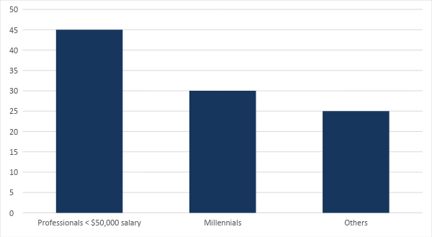

SWOT Analysis | Strengths | Weaknesses | Opportunities | Threats
Nzuri Cosmetics | Organic products with no animal testing | Low-profit margins as introductory prices | Market potential of beauty products | Dynamic nature of the beauty industry can prove difficult for the company to keep up
Maybelline New York | The wide product range offered to customers | Lack of social media presence | Increase per capita income results to an increase in shopping behaviors | Competition from other brands that offer similar products at similar prices
L’Oreal Paris | Known for product quality | Weak website in the age of e-commerce | Expansion of product lines | Lower profit margins can cause problems with overall cash flow

Marketing Strategy: [Nzuri Cosmetics] shall rely, for the most part, on social media marketing. Print and broadcast advertising, although useful, are now less popular for millennials and younger audiences. Influencer marketing will help promote the brand thanks to well-known figures within a specific industry.

By taking advantage of influencer marketing programs, the company will gain credibility through social media makeup artists, which will then encourage the acceptance of the brand to the public. With trendy colors, collaborators, and social media postings, the brand’s overall aesthetics, and low prices are sure to attract consumers in the long run.

Marketing Strategy | Activities | Timeline | Success Criteria
Print advertising | Produce print advertisements for influential magazines | April 2019 | Quality print advertisements to be run in at least three influential magazines: Cosmopolitan, Vogue, and W
Influencer Program | Tap at least 25 influencers who will post about the products on their social media pages | March 2019 | Each influencer will be able to use up promo coupons allocated for their followers (100 coupons each)
Social Media Marketing | Update and schedule social media posts | February 2019 | 150% increase in followers and post engagements.

Organizational Structure:

CEO
Operations Manager
Financial Officer
HR Manager
Store Manager
Marketing Manager
Tailoring Staff
Store Staff
HR Assistant

Operational Plan:

Location and Facilities
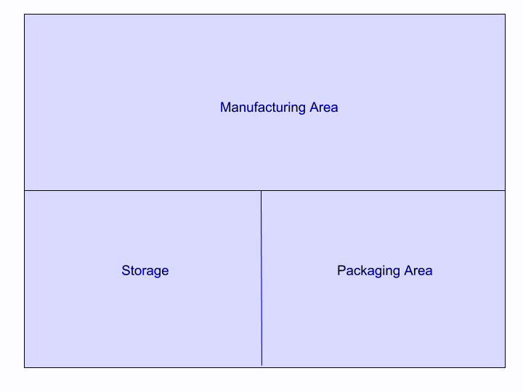

Financial Plan

Assumptions

Due to the nature of [cosmetic branding], the company is looking at slow but stable revenue growth. The business is a combination of retail and wholesale, thus, there will be delays on the sales collection. As the company develops its customer base, sales should increase by the third year.

Monthly Expense

The chart shows the projected monthly expense for the coming year.

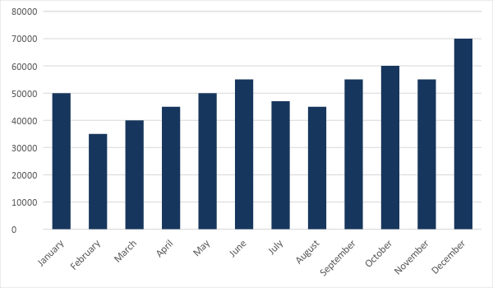

Monthly Revenue

The chart depicts the projected monthly revenue.

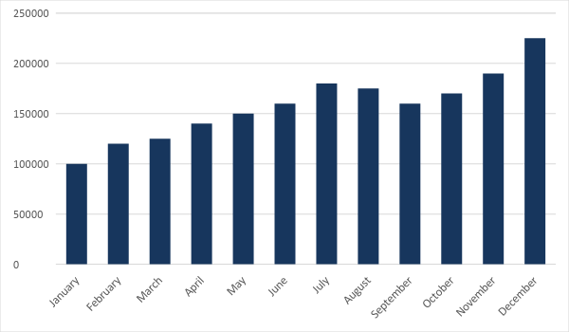
Business Financing

The business shall be funded by the [owner and CEO]. Most of the expenses shall go to insurance, rent, salaries, supplies, and advertising.

Statements

Profit and Loss Projection
 | FY2019 | FY2020 | FY2021
Sales | $4,000,000.00 | $4,500,000.00 | $5,000,000.00
Direct Cost of Sale | $1,200,000.00 | $1,500,000.00 | $1,700,000.00
Other Cost of Sale | $500,000.00 | $550,000.00 | $600,000.00
Total Cost of Goods Sold or COGS (Sales - Direct Cost of Sale - Other Cost of Sale) | $2,300,000.00 | $2,450,000.00 | $2,700,000.00
Gross Profit (Sales-Total Cost of Goods Sold) | $1,700,000.00 | $2,050,000.00 | $2,300,000.00
Gross Margin % (Gross Profit/Sales) | 42.50% | 45.56% | 46.00%
Operating Expenses
Rent | $36,000 | $36,000 | $36,000
Insurance | $5,000 | $5,000 | $5,000
Utilities | $5,000 | $5,000 | $5,000
Salary (Including Tax) | $1,500,000 | $1,500,000 | $2,000,000
Maintenance & Supplies | $24,000 | $24,000 | $24,000
Total Operating Expenses | $1,570,000.00 | $1,570,000.00 | $2,070,000.00
EBITDA (Total Cost of Sale-Total Operating Expenses) | $730,000.00 | $880,000.00 | $630,000.00
Depreciation | $4,000.00 | $4,000.00 | $4,000.00
Interest Expense | $0.00 | $0.00 | $0.00
Taxes Paid | $4,000.00 | $5,000.00 | $6,000.00
Net Profit (Gross Profit - Operating Expenses - Taxes - Interest) | $126,000.00 | $475,000.00 | $224,000.00

Balance Sheet Projection
 | FY2019 | FY2020 | FY2021
Cash | $1,500,000.00 | $1,650,000.00 | $1,700,000.00
Accounts Receivable | $10,000.00 | $15,000.00 | $11,000.00
Inventory | $3,000.00 | $5,000.00 | $6,000.00
Other Current Assets | $5,000.00 | $6,000.00 | $8,000.00
Total Current Assets | $1,518,000.00 | $1,676,000.00 | $1,725,000.00
Long-Term Assets | $800,000.00 | $700,000.00 | $600,000.00
Accumulated Depreciation | $3,000.00 | $2,500.00 | $2,000.00
Total Long-Term Assets (Long-Term Assets-Accumulated Depreciation) | $797,000.00 | $697,500.00 | $598,000.00
Total Assets (Total Current Assets + Total Long-Term Assets) | $2,315,000.00 | $2,373,500.00 | $2,323,000.00
Accounts Payable | $20,000.00 | $30,000.00 | $15,000.00
Notes Payable | $5,000.00 | $6,000.00 | $8,000.00
Other | $3,500.00 | $7,000.00 | $5,000.00
Total Liabilities | $28,500.00 | $43,000.00 | $28,000.00
Paid-in Capital | $5,000.00 | $5,000.00 | $5,000.00
Retained Earnings | $1,150,000.00 | $1,200,000.00 | $1,300,000.00
Total Owner's Equity (Total Assets - Total Liabilities) | $2,286,500.00 | $2,330,500.00 | $2,295,000.00
Total Liabilities & Equity (Total Liabilities/Total Owner's Equity) | 1.25% | 1.85% | 1.22%

Cash Flow Projection
 | FY2019 | FY2020 | FY2021
Operating Cash Beginning | $1,000,000.00 | $1,500,000.00 | $1,600,000.00
Sources of Cash | $1,500,000.00 | $1,800,000.00 | $1,500,000.00
Receivables | $150,000.00 | $170,000.00 | $200,000.00
Sales | $3,000,000.00 | $2,500,000.00 | $3,500,000.00
Others | $5,000.00 | $7,000.00 | $8,000.00
Total Cash | $5,655,000.00 | $5,977,000.00 | $6,808,000.00
Expenditures
Rent | $36,000 | $36,000 | $36,000
Insurance | $5,000 | $5,000 | $5,000
Utilities | $5,000 | $5,000 | $5,000
Salary (Including Tax) | $2,000,000 | $2,000,000 | $2,000,000
Maintenance & Supplies | $24,000 | $24,000 | $24,000
Total Expenditures | $2,070,000.00 | $2,070,000.00 | $2,070,000.00
Net Income/Loss (Total Cash - Total Expenditures) | $3,585,000.00 | $3,907,000.00 | $4,738,000.00

