CAFE OR COFFEE SHOP MARKETING PLAN
INDEX

EXECUTIVE SUMMARY  COMPANY OVERVIEW  PRODUCTS AND SERVICES  MARKETING ANALYSIS  STRATEGY AND IMPLEMENTATION  MANAGEMENT AND PERSONNEL  FINANCIAL PLAN | [INSERT PAGE NO.]  [INSERT PAGE NO.]  [INSERT PAGE NO.]  [INSERT PAGE NO.]  [INSERT PAGE NO.]  [INSERT PAGE NO.]  [INSERT PAGE NO.]

EXECUTIVE SUMMARY

[Marielle’s Coffee] is a locally-owned, specialty coffee shop that provides a friendly and productive atmosphere for students and professionals who want to study or work in a quiet but bustling environment.

With [60%] of [US] consumers visiting coffee shop chains at least once a month, consumer demand for premium products and experiences are expected to grow in the next three years. Aggressive marketing strategies are essential to the success and profitability of [Marielle’s Coffee]. These marketing strategies include online and social media advertising, promotional efforts, and taste testing activities.

COMPANY OVERVIEW

Mission Statement: [Marielle’s Coffee] aims to provide caffeine boosts to students and professionals, one cup at a time.

Philosophy: [Marielle’s Coffee] engages the community by providing individuals creative space and an environment conducive to learning.

Vision: [Marielle’s Coffee] wants to establish itself as a purveyor of the finest coffee in the local area.

Outlook: Coffee shops are among the fastest-growing businesses in the retail coffee and snacks store industry. According to the [National Coffee Association of America], the [US] coffee market is estimated to be [$50 billion dollars], with specialty coffee comprising [55%] of its value share.
Type of Industry: Retail Coffee and Snacks Store

Business Structure: Sole Proprietorship

Ownership: Sole Proprietorship, [Marielle Gomez]

Start-Up Summary: The start-up cost of [$50,000] shall be provided in full by the owner. This amount shall be used for operating costs including marketing, equipment, supplies, salary, and maintenance.

Start-Up Funding
Start-Up Expenses | $25,000
Start-Up Assets | $25,000
Total Funding Required | $50,000
Assets
Non-Cash Assets from Start-Up | $10,000
Cash Requirements from Start-up | $5,000
Additional Cash Raised | $7,000
Cash Balance on Starting Date | $3,000
Total Assets | $25,000
Capital
Planned Investment
Owner | $50,000
Other | $0
Additional Investment Requirement | $0
Total Planned Investment | $50,000
Loss at Start-Up (Start-Up Expenses) | -$25,000
Total Capital | $25,000
Total Capital and Liabilities | $25,000
Start-Up
Requirements
Start-Up Expenses
Rent - 6 Months | $6,000
Advertising | $1,000
Legal Fees | $1,000
Staff Training | $12,000
Insurance | $1,000
Other | $4,000
Total Start-Up Expenses | $25,000
Start-Up Assets
Cash Required | $5,000
Start-Up Inventory | $3,000
Other Current Assets | $5,000
Long-Term Assets | $12,000
Total Assets | $25,000
Total Requirements (Total Start-Up Expenses + Total Assets) | $50,000

PRODUCTS AND SERVICES

Product/Service Description: [Marielle’s Coffee] offers specialty coffee, sandwiches, and pastries for customer consumption.

Value Proposition: Despite being a start-up company, [Marielle’s Coffee] is a member of the Specialty Coffee Association, and adheres to the high-quality SCA Standards.

Pricing Strategy: [Marielle’s Coffee] uses a combination of menu strategies, price bundling, and customer loyalty discounts.

MARKETING ANALYSIS

At least [60%] of [US] consumers visit coffee shop chains at least once a month. Coffee shop operations are influenced by consumer demand for good coffee. About a quarter of coffee consumers indicate coffee quality as the biggest motivation for repeat visits, which leads coffee producers to believe that good coffee trumps other trends in this business sector.

Market Segmentation

The primary target market of [Marielle’s Coffee] are adults aged [25-35], who account for [35%] of the total coffee consumers, most of which are in the upper-middle to high-income bracket. Its secondary target market includes adults aged [18-24], positioning itself as a place where students can hang out, study, write papers, and meet friends.
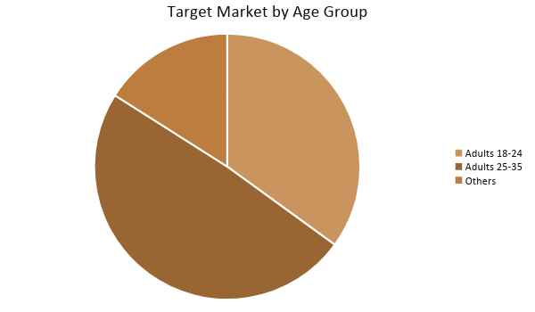

Target Market Segmentation Strategy

Customers between [25-35]

- [Marielle’s Coffee] will appeal to this consumer group by creating a space for professionals.
- This consumer group is the target for customer loyalty discounts to encourage them to visit the coffee shop on a regular basis.

Customers between [18-24]

- [Marielle’s Coffee] will appeal to this consumer group, made up of college students, by providing them with fast Internet access and an environment that is conducive to learning so that they may study, write their papers, or have conversations with their friends.
- This consumer group is the target of the price bundling strategy. The savings marketed for combo meals and snacks will encourage them to order food with their drinks.

STRATEGY AND IMPLEMENTATION

Target Market Strategy

In its aim to increase sales by [8%] in the first year, [Marielle’s Coffee] will reach out to its target audience by conducting coffee-related events such as coffee cupping and latte art seminars, The company will also engage in online marketing efforts such as social media advertising, and feature in local papers and magazines.

Competitive Edge

[Marielle’s Coffee] has an advantage over other local coffee shops, thanks to its membership with the SCA, and its combination of pricing strategies to fit any person’s budget.

SWOT Analysis | Strengths | Weaknesses | Opportunities | Threats
Marielle’s Coffee | One of the few coffee shops in the area that is a member of the SCA | Limited brand equity | The growing market sees an increase in customer base and revenue | The high cost of market entry can prove problematic
Daily Brew | Strong relationship with 3rd-party vendors and suppliers | Very limited menu | Customizing marketing strategies based on location and target market | Problems in the economy will decrease customer spending
Cuppa Coffee | Excellent staff and great customer service | Limited marketing budget | Strategic alliance with other businesses helps revenue growth | Newly opened coffee shops pose a threat

Sales Strategy and Forecast

With different marketing strategies and social media efforts, the company targets the following monthly sales:
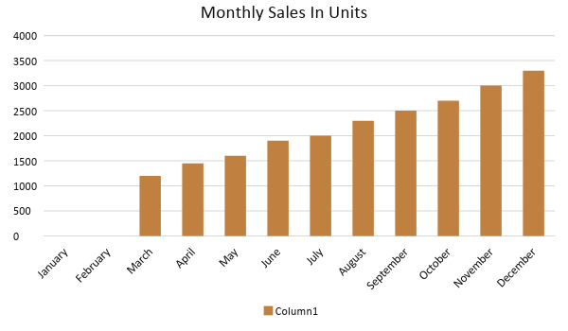

By remaining consistent with its coffee quality and exemplary customer service (internal marketing efforts), the table below depicts the projected percentage growth of [Marielle’s Coffee] in [two years]:

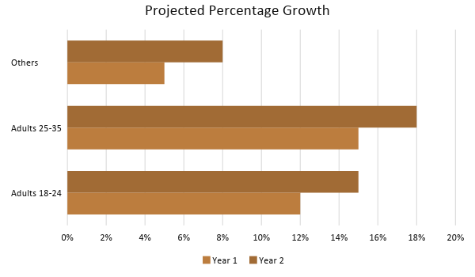

Marketing Strategy

[Marielle’s Coffee] plans on utilizing both internal and external marketing practices. By maintaining product quality and great customer service, the coffee shop hopes to see repeat business from customers.

The company also hired a marketing manager to help execute marketing strategies such as coffee-related events, maintaining and curating social media accounts and adverts, and writing product features for local magazines.

The strategies to be implemented are discussed in the next table.

Milestones

Marketing Strategy | Activities | Timeline | Success Criteria
- Website development  - Social media pages and advertisements | - Create an official website  - Create content for social media | January 15, 2019 | - 5,000 website hits in 3 months  - 1,500 likes and follows on Facebook, Twitter, and Instagram
Newspaper and magazine feature of the coffee shop | Publish feature highlighting the coffee shop | March 30, 2019 | - The coffee shop is featured in two local papers.  - The coffee shop is featured in a local magazine and three food blogs.
Event Campaign: - Produce 1 coffee-related event per month | Possible events:  - Coffee cupping  - Latte Art Seminar  - Barista Training | Every 2nd Saturday of the Month | - High social media engagement  - Fill up available slots every month (may range from 30-50)

MANAGEMENT AND PERSONNEL

As a small sole proprietor coffee shop, [Marielle’s Coffee] consists of a small team of personnel. Marielle Gomez, the owner, serves as the CEO and coffee shop manager. Security, maintenance, and the coffee shop staff report directly to her.

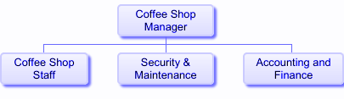

FINANCIAL PLAN

The following financial plan includes projections on the coffee shop’s break-even analysis, profit and loss, balance sheet, and cash flow.

Break-Even Analysis

Fixed Costs | Average Price | Variable Costs | Contribution Margin | Break-Even Units
$20,000.00 | $4.00 | $1.50 | $2.50 | 8,000.00

Fixed Costs | Amount |  | Variable Costs | Per Unit Amount
Rent | 6,000 |  | Production Costs | 0.75
Insurance | 1,000 |  | Utilities | 0.75
Legal Fees | 1,000
Staff Training | 12,000
Total | 20,000 |  | Total | 1.5

Fixed Costs
Business Lease - Rent (6 Months) |  | $6,000
Insurance |  | $1,000
Legal Fees |  | $1,000
Staff Training |  | $12,000
Total Fixed Costs |  | $20,000
Total Units Sold in 1 Month |  | 1,250
Variable Costs (Unit Sold/Cost per Unit)
Production Costs | $1,670 | $0.75
Utility Costs | $1,660 | $0.75
Total Variable Cost (Per Unit) |  | $1.50
Break-Even
Selling Price Per Unit |  | $4.00
Break-Even Point Per Unit [Fixed Costs/(Sales Price Per Unit - Variable Cost Per Unit)] |  | 20,000
 |  | 2.50
Break-Even Point in Units |  | 8,005
Contribution Margin (Selling Price - Total Variable Cost) |  | $2.50

Profit and Loss Projection
 | FY2019 | FY2020 | FY2021
Sales | $200,000.00 | $250,000.00 | $300,000.00
Direct Cost of Sale | $180,000.00 | $195,000.00 | $200,000.00
Other Cost of Sale | $10,000.00 | $13,000.00 | $15,500.00
Total Cost of Goods Sold or COGS (Sales - Direct Cost of Sale - Other Cost of Sale) | $10,000.00 | $42,000.00 | $84,500.00
Gross Profit (Sales-Total Cost of Goods Sold) | $190,000.00 | $208,000.00 | $215,500.00
Gross Margin % (Gross Profit/Sales) | 95.00% | 83.20% | 71.83%
Operating Expenses
Rent | $12,000.00 | $12,000.00 | $12,000.00
Insurance | $1,000.00 | $1,000.00 | $1,000.00
Utilities | $8,000.00 | $8,000.00 | $8,000.00
Salary (Including Tax) | $36,000.00 | $36,000.00 | $36,000.00
Maintenance & Supplies | $3,000.00 | $4,000.00 | $4,500.00
Total Operating Expenses | $60,000.00 | $61,000.00 | $61,500.00
EBITDA (Total Cost of Sale-Total Operating Expenses) | -$50,000.00 | -$19,000.00 | $23,000.00
Depreciation | $4,000.00 | $4,000.00 | $4,000.00
Interest Expense | $0.00 | $0.00 | $0.00
Taxes Paid | $4,000.00 | $5,000.00 | $6,000.00
Net Profit (Gross Profit - Operating Expenses - Taxes - Interest) | $126,000.00 | $142,000.00 | $148,000.00

Balance Sheet Projection
 | FY2019 | FY2020 | FY2021
Cash | $5,000.00 | $165,000.00 | $170,000.00
Accounts Receivable | $130,000.00 | $150,000.00 | $170,000.00
Inventory | $3,000.00 | $5,000.00 | $6,000.00
Other Current Assets | $50,000.00 | $60,000.00 | $8,000.00
Total Current Assets | $188,000.00 | $380,000.00 | $354,000.00
Long-Term Assets | $12,000.00 | $7,000.00 | $6,000.00
Accumulated Depreciation | $1,200.00 | $2,500.00 | $2,000.00
Total Long-Term Assets (Long-Term Assets-Accumulated Depreciation) | $10,800.00 | $4,500.00 | $4,000.00
Total Assets (Total Current Assets + Total Long-Term Assets) | $198,800.00 | $384,500.00 | $358,000.00
Accounts Payable | $10,000.00 | $30,000.00 | $15,000.00
Notes Payable | $5,000.00 | $6,000.00 | $8,000.00
Other | $3,500.00 | $7,000.00 | $5,000.00
Total Liabilities | $18,500.00 | $43,000.00 | $28,000.00
Paid-in Capital | $5,000.00 | $5,000.00 | $5,000.00
Retained Earnings | $126,000.00 | $142,000.00 | $148,000.00
Total Owner's Equity (Total Assets - Total Liabilities) | $180,300.00 | $341,500.00 | $330,000.00
Total Liabilities & Equity (Total Liabilities/Total Owner's Equity) | 10.26% | 12.59% | 8.48%

Cash Flow Projection
 | FY2019 | FY2020 | FY2021
Operating Cash Beginning | $30,000.00 | $187,000.00 | $395,000.00
Sources of Cash | $5,000.00 | $7,000.00 | $10,000.00
Receivables | $7,000.00 | $5,000.00 | $7,500.00
Sales | $200,000.00 | $250,000.00 | $300,000.00
Others | $5,000.00 | $7,000.00 | $8,000.00
Total Cash | $247,000.00 | $456,000.00 | $720,500.00
Expenditures
Rent | $12,000.00 | $12,000.00 | $12,000.00
Insurance | $1,000.00 | $1,000.00 | $1,000.00
Utilities | $8,000.00 | $8,000.00 | $8,000.00
Salary (Including Tax) | $36,000.00 | $36,000.00 | $36,000.00
Maintenance & Supplies | $3,000.00 | $4,000.00 | $4,500.00
Total Expenditures | $60,000.00 | $61,000.00 | $61,500.00
Net Income/Loss (Total Cash - Total Expenditures) | $187,000.00 | $395,000.00 | $659,000.00

