BUSINESS CONSULTANT MARKETING PLAN

[INSERT NAME OF THE BUSINESS/COMPANY]

[INSERT DATE]

Index

Executive Summary [PAGE NUMBER]
Company Overview [PAGE NUMBER]
Products and Services [PAGE NUMBER]
Marketing Analysis [PAGE NUMBER]
Strategy and Implementation [PAGE NUMBER]

Management and Personnel [PAGE NUMBER]
Financial Plan [PAGE NUMBER]

EXECUTIVE SUMMARY

Over the years, small businesses are experiencing hardships in an increasingly competitive global market. Businesses are forced to look for specialists to help them become more competitive and profitable. Globalization has given rise to business solution firms.

[Pullman Business Solutions] (PBS) is a business consultancy firm that specializes in crisis management, opportunity identification, marketing, operation practices, and expansion. [PBS] helps small to mid-sized businesses earn profits. [PBS] is unique for its consultants who are top professional experts in their fields. It is not just a consulting firm, but a partner to its clients. It works with them to discover better opportunities and guide them in becoming bigger players in their industry.

[PBS] offers competitive pricing that is affordable to its target market.

COMPANY OVERVIEW

Mission Statement: The company’s mission is to help small to mid-sized firms in crisis management and identifying areas for growth.

Philosophy: [PBS] prides itself in its professionalism, confidentiality, and business expertise partnered with client-focused values. It takes a holistic view of its client to assess its strengths and weaknesses.

Vision: “With our business expertise, [PBS] will be your partner in steering your company to meaningful growth.”

Outlook: In the past few years, many small and mid-sized businesses have opened businesses in different industries. Some of them have grown into bigger businesses, but most have to deal with different crises. To help these companies, business consultancy groups—third-party groups that specialize in crisis aversion and management, and recognizing areas for growth and expansion—started offering their expertise.

Type of Industry: [Business Consultancy]

Business Structure: Partnership

Ownership: [David Pullman and Jackson Pullman]

Start-Up Summary: The cost for the start-up is [50K USD] provided by the owners and to be used mainly for the rent, insurance, supplies, and payroll.

Start-Up Funding
Start-Up Expenses | $20,000
Start-Up Assets | $30,000
Total Funding Required | $50,000
Assets
Non-Cash Assets from Start-Up | $10,000
Cash Requirements from Start-up | $10,000
Additional Cash Raised | $5,000
Cash Balance on Starting Date | $5,000
Total Assets | $30,000
Capital
Planned Investment
Owner | $30,000
Other | $0
Additional Investment Requirement | $0
Total Planned Investment | $30,000
Loss at Start-Up (Start-Up Expenses) | -$20,000
Total Capital | $10,000
Total Capital and Liabilities | $10,000
Start-Up
Requirements
Start-Up Expenses
Rent - 5 Months | $5,000
Advertising | $5,000
Legal Fees | $1,000
Staff Training | $3,000
Insurance | $1,000
Other | $5,000
Total Start-Up Expenses | $20,000
Start-Up Assets
Cash Required | $10,000
Start-Up Inventory | $10,000
Other Current Assets | $5,000
Long-Term Assets | $5,000
Total Assets | $30,000
Total Requirements (Total Start-Up Expenses + Total Assets) | $50,000

PRODUCTS AND SERVICES

Product/Service Description: [Pullman Business Solutions] provides business consultancy services in management and strategy, marketing, human resources, and operations.

Value Proposition: [PBS] consultants are the leading experts in their field backed by years of knowledge and experience. It works in partnership with top firms to implement the needed changes and practices and keep their businesses moving forward.

Pricing Strategy: As one of the leading business solution firms that serve small to mid-sized businesses, [PBS] offers competitive pricing for its services.

Marketing Analysis

With the global market expanding, many businesses are taking the opportunity to sell their products and expertise. This, in turn, has made the business environment more competitive and volatile than ever. However, many small and mid-sized firms are not equipped to face these challenges. Thus, the business solution industry continues to grow in response to the demand for consultancy services.

Market Segmentation

[PBS] focuses on consulting with mid-sized firms particularly on the management and strategy, marketing, human resources, and operational aspects of their business. The four major industries that [PBS] currently consults with are in the field of hospitality, food and beverages, retail, and entertainment.

The graph below shows the classification of its clients.

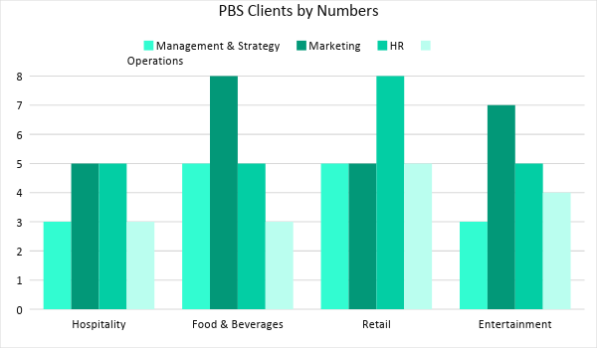

Target Market Segmentation Strategy

- Clients in the hospitality business consult more on marketing and HR practices.
- In the food and beverage sector, most consultees need help in implementing better marketing strategies.
- In the retail side, [PBS] clients often have high turnover rates in their workforce which implies the need for better HR practices.
- Lastly, in the entertainment sector, [PBS] clients are experiencing lesser demand for products and services.
- [PBS] started training consultants to specifically cater to these needs.

STRATEGY AND IMPLEMENTATION

Target Market Strategy

For its second year goal, [PBS] is targeting an increase of its sales by at least [10%] from the first year. To accomplish this, [PBS] is planning to hire more business solution experts to be able to service more clients.

Competitive Edge

With the firm’s competitive pricing plus bespoke top-of-their-field consultants, [PBS] has the edge over its competition.

SWOT Analysis | Strengths | Weaknesses | Opportunities | Threats
PBS | - Manned by top business solution experts  - Competitive price  - Professional and client-focused  - Focused on four industries | - Relatively new in the business  - Need more consultants to cope with the service demands | - Demand for consultancy is increasing  - Opportunities to expand to new industries | - Talent poaching
Box & Troy | - The biggest business consultancy in the state  - Can offer very low service price | - Not client-focused  - Cares more for its own reputation | - Ability to offer consultants with higher pay | - Smaller firms offer better service at a competitive price
We Solve, Inc. | - Established clientele | - Has yet to expand  - Expensive | - New businesses mean new opportunities to add new clients | - Clients are looking for cheaper solution firms

Sales Strategy and Forecast

With the hiring of new consultants, [PBS] targets the following monthly sales for its second year:

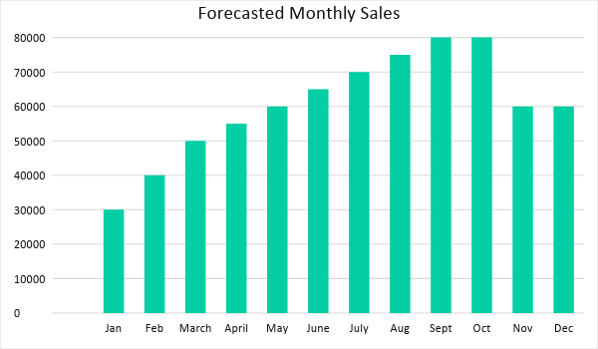

By hiring additional business solution experts, [PBS] aims to satisfy the service demands in its second year. [PBS] also targets to expand its clients.

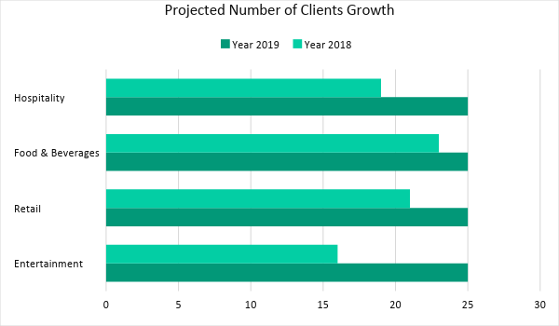

Marketing Strategy

Although [PBS] has had a successful first year, it has struggled in coping with the service demand. By the end of the first year, [PBS] has started recruiting and hiring more business solution experts. The firm will start training the newly hired consultants by the second week of January and have them on field duty after a month of training.

The firm also plans to continue executing its marketing strategies, such as digital advertisements, free business talks and forums, distribution of service kits and magazines, and print ads. Recently, PBS has also recruited SEO specialists to improve its digital presence and digital marketing strategy.

The firm started its training last week. Here are some of the updates:

Milestones

Marketing Strategy | Activities | Timeline | Success Criteria
Specialist Training | - Training is on its second week | February 10, 2019 | The new consultants will be in the field by the second week of February.
Improve Digital Marketing | - Hire SEO specialists | January 12, 2019 | Hired two SEO specialists last January 20, 2018.
Implementation of a Digital Marketing Calendar | - The first draft is currently in review with management | February 25, 2019 | A final draft should be approved before the end of February.
Business Talk | - Hold a business forum inviting clients and prospects | March 14, 2019 | Event draft with names of the speakers should be approved by Feb. 20, 2019. Invitations should be sent by the 25th of the month.

MANAGEMENT AND PERSONNEL

[David Pullman] serves as the [CEO] of the company. Meanwhile, Jackson Pull serves as the [COO] and [CFO].

The general manager oversees all the operations of the firm and reports directly to the [CEO] and [COO]. The general manager will manage the three departments:

- The marketing team handles client acquisition and marketing including the newly established digital marketing team.

- The sales team is in charge of selling services to prospective clients.

- The consultancy team goes out into the field and provide the services to the clients.

The [CFO] is responsible for the finances of the firm. This includes revenue generation and research and development of possible services to be offered.

Pullman Business Solutions Organizational Chart:

CEO
General Manager
COO/CFO
Marketing Director
Sales Director
Consultant Manager
Digital Marketing
Sales Pod 1
Consultant Team 1
Customer Acquisition
Revenue Generation
Sales Pod 2
Sales Pod 3

Consultant Team 2

Consultant Team 3
Consultant Team 4
Consultant Team 5
HR

FINANCIAL PLAN

[PBS] second-year financial plan includes the projected break-even analysis, profit and loss, balance sheet, and cash flow.

Based on the first year, the biggest expenses for this year will be salary. It will continue to increase as the firm has hired new consultants as well as two SEO specialists. However, PBS sees growth in profit for this year as the newly hired consultants are expected to bring in new clients.

Break-Even Analysis

Fixed Costs | Average Price | Variable Costs | Contribution Margin | Break-Even Units
$13,000.00 | $5,000.00 | $3,000.00 | $4,999.98 | 3.00
Fixed Costs | Amount |  | Variable Costs | Per Unit Amount
Rent | 12,000 |  | Advertising | $0.01
Insurance | 1,000 |  | Legal Fees | $0.01
 |  |  | Staff Training | $0.01
Total | 13,000 |  | Total | $0.02
Fixed Costs
Business Lease - Rent |  | $12,000
Insurance |  | $1,000
Total Fixed Costs |  | $13,000
Total Units Sold in 1 Month |  | 5
Variable Costs (Unit Sold/Cost per Unit)
Advertising | $1,000 | $0.01
Legal Fees | $1,000 | $0.01
Staff Training | $1,000 | $0.01
Total Variable Cost (Per Unit) |  | $0.02
Break-Even
Selling Price Per Unit |  | $5,000.00
Break-Even Point Per Unit [Fixed Costs/(Sales Price Per Unit - Variable Cost Per Unit)] |  | 13,000
 |  | 4,999.98
Break-Even Point in Units |  | 3
Contribution Margin (Selling Price - Total Variable Cost) |  | $4,999.98

Profit and Loss Projection
 | FY2018 | FY2019 | FY2020
Sales | $300,000.00 | $725,000.00 | $850,000.00
Direct Cost of Sale | $100,000.00 | $200,000.00 | $300,500.00
Other Cost of Sale | $12,000.00 | $12,000.00 | $12,000.00
Total Cost of Goods Sold or COGS (Sales - Direct Cost of Sale - Other Cost of Sale) | $188,000.00 | $513,000.00 | $537,500.00
Gross Profit (Sales-Total Cost of Goods Sold) | $112,000.00 | $212,000.00 | $312,500.00
Gross Margin % (Gross Profit/Sales) | 37.33% | 29.24% | 36.76%
Operating Expenses
Rent | $40,000.00 | $40,000.00 | $40,000.00
Insurance | $10,000.00 | $15,000.00 | $25,000.00
Utilities | $20,000.00 | $23,000.00 | $26,000.00
Salary (Including Tax) | $80,000.00 | $90,000.00 | $100,000.00
Maintenance & Supplies | $5,000.00 | $5,000.00 | $5,500.00
Total Operating Expenses | $155,000.00 | $173,000.00 | $196,500.00
EBITDA (Total Cost of Sale-Total Operating Expenses) | $33,000.00 | $340,000.00 | $341,000.00
Depreciation | $2,000.00 | $2,000.00 | $2,000.00
Interest Expense | $0.00 | $0.00 | $0.00
Taxes Paid | $4,000.00 | $5,000.00 | $6,000.00
Net Profit (Gross Profit - Operating Expenses - Taxes - Interest) | -$47,000.00 | $34,000.00 | $110,000.00

Balance Sheet Projection
 | FY2018 | FY2019 | FY2020
Cash | $250,000.00 | $265,000.00 | $270,000.00
Accounts Receivable | $50,000.00 | $55,000.00 | $70,000.00
Inventory | $3,000.00 | $5,000.00 | $6,000.00
Other Current Assets | $5,000.00 | $6,000.00 | $8,000.00
Total Current Assets | $308,000.00 | $331,000.00 | $354,000.00
Long-Term Assets | $8,000.00 | $7,000.00 | $6,000.00
Accumulated Depreciation | $3,000.00 | $2,500.00 | $2,000.00
Total Long-Term Assets (Long-Term Assets-Accumulated Depreciation) | $5,000.00 | $4,500.00 | $4,000.00
Total Assets (Total Current Assets + Total Long-Term Assets) | $313,000.00 | $335,500.00 | $358,000.00
Accounts Payable | $50,000.00 | $50,000.00 | $50,000.00
Notes Payable | $10,000.00 | $10,000.00 | $10,000.00
Other | $5,000.00 | $7,000.00 | $5,000.00
Total Liabilities | $65,000.00 | $67,000.00 | $65,000.00
Paid-in Capital | $5,000.00 | $5,000.00 | $5,000.00
Retained Earnings | $115,000.00 | $120,000.00 | $130,000.00
Total Owner's Equity (Total Assets - Total Liabilities) | $248,000.00 | $268,500.00 | $293,000.00
Total Liabilities & Equity (Total Liabilities/Total Owner's Equity) | 26.21% | 24.95% | 22.18%

Cash Flow Projection
 | FY2018 | FY2019 | FY2020
Operating Cash Beginning | $30,000.00 | $248,000.00 | $300,000.00
Sources of Cash | $10,000.00 | $18,000.00 | $5,000.00
Receivables | $5,000.00 | $5,000.00 | $3,000.00
Sales | $525,000.00 | $725,000.00 | $700,000.00
Others | $5,000.00 | $0.00 | $5,000.00
Total Cash | $575,000.00 | $996,000.00 | $1,013,000.00
Expenditures
Rent | $55,000.00 | $55,000.00 | $55,000.00
Insurance | $12,000.00 | $20,000.00 | $30,000.00
Utilities | $30,000.00 | $45,000.00 | $50,000.00
Salary (Including Tax) | $220,000.00 | $480,000.00 | $500,000.00
Maintenance & Supplies | $10,000.00 | $20,000.00 | $30,500.00
Total Expenditures | $327,000.00 | $620,000.00 | $665,500.00
Net Income/Loss (Total Cash - Total Expenditures) | $248,000.00 | $376,000.00 | $347,500.00

