[ABC Company]
[991 Ketch Harbour Ave. Evansville, IN 47711]
[+1-202-555-0127]
[abccompany@email.com]
Budget Worksheet
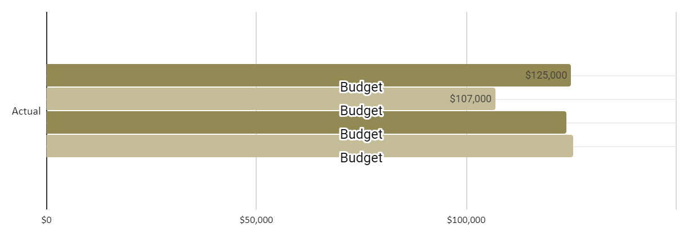
INCOME
Sales | Actual | % | Budget | % | Difference
Notebook | $100,000 | 31% | $90,000 | 31% | $10,000
Desktop | $150,000 | 47% | $100,000 | 34% | $50,000
Printer | $70,000 | 22% | $100,000 | 34% | -$30,000
Other
Total Sales (TS) | $320,000 | 100% | $290,000 | 100% | $290,001
Cost of Goods Sold | Actual | % | Budget | % | Difference
COGS Notebook | $110,000 | 100% | $96,000 | 100% | -$1,000
COGS Desktop | $95,000 | 100% | $96,000 | 100% | -$1,000
COGS Printer | $90,000 | 100% | $96,000 | 100% | -$6,000
Total Cost of Goods Sold | $295,000 | 300% | $288,000 | 300% | -$8,000
Gross Profit | $25,000 | -200% | $2,000 | -200% | $298,001
Non-Operating Income | Actual | % | Budget | % | Difference
Interest Income | $50,000 | 50% | $55,000 | 52% | -$5,000
Income from Rent | $50,000 | 50% | $50,000 | 48% | $0
Gifts Received | $0 | 0% | $0 | 0% | $0
Total Non-Operating Income | $100,000 | 100% | $105,000 | 100% | -$5,000
TOTAL INCOME | $125,000 |  | $107,000 |  | $293,001
EXPENSES
Operating Expenses | Actual | % | Budget | % | Difference
Accounting and Legal | $11,000 | 9% | $10,000 | 8% | $1,000
Advertising | $10,000 | 9% | $10,000 | 8% | $0
Insurance | $6,000 | 5% | $6,000 | 5% | $0
Maintenance and Repairs | $5,000 | 4% | $3,000 | 2% | $2,000
Office Supplies | $4,000 | 3% | $4,000 | 3% | $0
Payroll Expenses | $15,000 | 13% | $20,000 | 17% | -$5,000
Rent | $10,000 | 9% | $10,000 | 8% | $0
Research and Development | $2,000 | 2% | $2,000 | 2% | $0
Salaries and Wages | $50,000 | 43% | $50,000 | 41% | $0
Taxes and Licenses | $1,000 | 1% | $1,500 | 1% | -$500
Telephone | $900 | 1% | $1,000 | 1% | -$100
Travel | $2,500 | 2% | $3,000 | 2% | -$500
Total Operating Expenses | $117,400 | 100% | $120,500 | 100% | -$3,100
Non-Recurring Expenses | Actual | % | Budget | % | Difference
Furniture, Equipment and Software | $6,500 | 100% | $5,000 | 100% | $1,500
Gifts Given | $0 | 0% | $0 | 0% | $0
Other
Total Non-Recurring Expenses | $6,500 | 100% | $5,000 | 100% | $1,500
TOTAL EXPENSES | $123,900 | 200% | $125,500 | 200% | -$1,600
Net Income Before Taxes | $1,100 |  | -$1 |  | $1,101
Income Tax Expense |  |  |  |  | $0
NET INCOME | $1,100 |  | -$1 |  | $1,101

COST OF GOODS - Details
Notebook | Actual | % | Budget | % | Difference
Opening Inventory | $50,000 | 45% | $50,000 | 47% | $0
Goods Purchased or Manufactured | $10,000 | 9% | $10,000 | 9% | $0
Transportation | $15,000 | 14% | $10,000 | 9% | $5,000
Labor (wages and payroll) | $10,000 | 9% | $11,000 | 10% | -$1,000
Closing Inventory | $25,000 | 23% | $25,000 | 24% | $0
Others
Cost of Goods Sold | $110,000 | 100% | $106,000 | 100% | $4,000
Profit (Loss) | -$10,000 | 69% | -$16,000 | 69% | $6,000
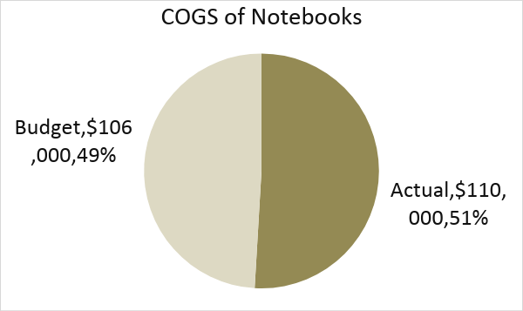

Desktop | Actual | % | Budget | % | Difference
Opening Inventory | $50,000 | 53% | $50,000 | 52% | $0
Goods Purchased or Manufactured | $15,000 | 16% | $15,000 | 16% | $0
Transportation | $10,000 | 11% | $10,000 | 10% | $0
Labor (wages and payroll) | $10,000 | 11% | $11,000 | 11% | -$1,000
Closing Inventory | $10,000 | 11% | $10,000 | 10% | $0
Others
Cost of Goods Sold | $95,000 | 100% | $96,000 | 100% | -$1,000
Profit (Loss) | $55,000 | 53% | $4,000 | 66% | $51,000
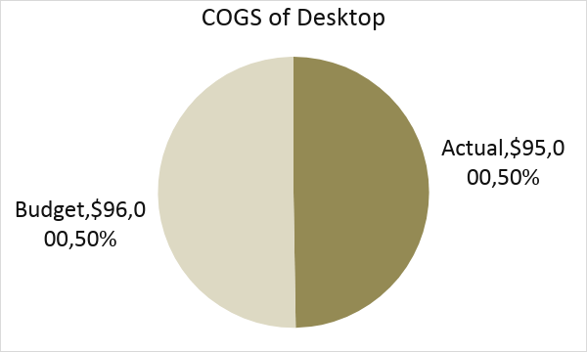

Printer | Actual | % | Budget | % | Difference
Opening Inventory | $50,000 | 56% | $50,000 | 52% | $0
Goods Purchased or Manufactured | $10,000 | 11% | $15,000 | 16% | -$5,000
Transportation | $10,000 | 11% | $10,000 | 10% | $0
Labor (wages and payroll) | $10,000 | 11% | $11,000 | 11% | -$1,000
Closing Inventory | $10,000 | 11% | $10,000 | 10% | $0
Others
Cost of Goods Sold | $90,000 | 100% | $96,000 | 100% | -$6,000
Profit (Loss) | -$20,000 | 78% | $4,000 | 66% | $6,000

