Budget Sheet
Income | Amount | 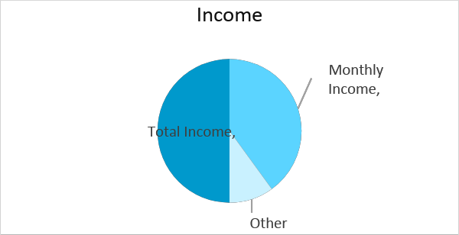
Monthly Income | $20,000.00
Other Income | $5,000.00
Total Income | $25,000.00
Expenses | Budget | Actual | Difference | Note
Mortgage | $5,000.00 | $5,000.00 | $0.00
Insurance | $3,000.00 | $3,000.00 | $0.00
Home Maintenance | $3,000.00 | $2,500.00 | $500.00
Groceries | $500.00 | $700.00 | -$200.00
Dinning Out | $2,500.00 | $3,000.00 | -$500.00
Cleaning Services | $150.00 | $170.00 | -$20.00
Vehicle Insurance | $1,500.00 | $1,000.00 | $500.00
Public Transportation | $2,000.00 | $2,200.00 | -$200.00
Internet Connections | $500.00 | $600.00 | -$100.00
Magazines | $300.00 | $500.00 | -$200.00
Prescriptions | $1,000.00 | $1,150.00 | -$150.00
Travel Fares | $3,000.00 | $3,500.00 | -$500.00
Total Expenses | $22,450.00 | $23,320.00 | -$870.00
