BRIDAL SHOP BUSINESS PLAN

Business Plan For Fiscal Year 2019

[January 31, 2019]

[Mallory G. Williams]
[mallorywilliams@gmail.com]
[419-237-1085]
[www.prettywhitebridal.com]
[3774 Davis Place]
[Fayette, Ohio 43521, USA]

Index

Executive Summary
Company Overview

Products and Services

Execution

Operational Plan
Financial Plan

EXECUTIVE SUMMARY

[Pretty White Bridal Salon] will be a one-stop shop at [Fayette], [Ohio] for all the needs of a bride on her big day. The company is owned by renowned wedding dress expert, [Mallory Williams]. It will offer the best quality bridal packages at affordable price ranges. Improving the public’s awareness of the shop is the business’ first step to achieving its projected [2]% increase in sales in the first two years.

COMPANY OVERVIEW

Mission Statement

[Pretty White Bridal Salon] aims to provide excellent quality gowns, shoes, undergarments, and bridal accessories.

Philosophy

The company focuses on the value of empathy and holistic care so that the pressures of the big day are made lighter for each bride/client. [Pretty White Bridal Salon] aims to break conventional practices and seeks to provide the bride with all that she needs to be beautiful on her wedding day in just one shop in a single visit.

Outlook

The business desires to achieve an increase of [5]% in sales in the next two years. By the end of [2023], the business envisions itself as a contender for the top position in the market.

Type of Industry: Retail Industry

Business Structure: Sole Proprietorship

Ownership: Sole Proprietorship, [Mallory G. Williams]

Start-Up Summary

The start-up cost of [Pretty White Bridal Salon] is [100K] USD. This amount covers the rent, insurance, inventory, and payroll of the business. The owner will shoulder the payment of the business’ start-up cost.

Start-Up Funding
Start-Up Expenses | $30,000
Start-Up Assets | $70,000
Total Funding Required | $100,000
Assets
Non-Cash Assets from Start-Up | $33,000
Cash Requirements from Start-up | $25,000
Additional Cash Raised | $7,000
Cash Balance on Starting Date | $5,000
Total Assets | $70,000
Capital
Planned Investment
Owner | $60,000
Other | $0
Additional Investment Requirement | $0
Total Planned Investment | $60,000
Loss at Start-Up (Start-Up Expenses) | -$30,000
Total Capital | $30,000
Liabilities | $0
Total Capital and Liabilities | $30,000
Start-Up
Requirements
Start-Up Expenses
Rent - 6 Months | $12,000
Advertising | $6,000
Legal Fees | $3,000
Staff Training | $6,000
Insurance | $2,000
Other | $1,000
Total Start-Up Expenses | $30,000
Start-Up Assets
Cash Required | $37,000
Start-Up Inventory | $10,000
Other Current Assets | $13,000
Long-Term Assets | $10,000
Total Assets | $70,000
Total Requirements (Total Start-Up Expenses + Total Assets) | $100,000

Management Team:

Management Team | Role/Function | Skills
[Sally Harper] | Marketing Director | Communication, Strategic Thinker, and Creativity
[Barbara Paulin] | Operations Manager | Conflict Management, Leadership, Decision-Making, and Organization
[Rachel Clement] | Finance Manager | Detail-Oriented and Analytical

Short- and Long-Term Goals and Milestones:

Short-Term Goals | Milestones
Recruit operations and finance managers as well as designers to assist [Ms. Mallory G. Williams] | - Hired an operations manager last [December 22, 2017].  - Recruitment of a finance manager will end by the second week of [January] [2018].  - Recruited 3 designers out of 5
Contract a reliable supplier of bridal accessories, textile, and shoes | - Contacted all qualified suppliers for bridal accessories, textiles, and shoes  - About [50]% of the suppliers have sent price quotations and the business has started reviewing them
Long-Term Goals | Milestones
Obtain positive customer feedback through quick and effective services | - The opening of a customer service hotline to answer all customer questions
Establish a stable position and business presence in the market | - Putting up of poster and newspaper ads to increase public awareness of the bridal shop

PRODUCTS AND SERVICES

Product/Service Description

[Pretty White Bridal Salon] provides clear-cut wedding dresses made specifically for each bride’s preference. The business also offers bridal undergarments, veil, headpiece, jewelry, and footwear to complement the bride’s made-to-order and specifically designed wedding dress. There are different packages that the bride can choose from depending on the cost of the wedding dress and the bridal accessories.

Value Proposition

A one-stop bridal shop. [Pretty White Bridal Salon] seeks to realize, in one sitting or one place, a bride’s fantasy and imagination of herself on her wedding day.

Pricing Strategy

[Pretty White Bridal Salon] offers standard bridal packages ranging from [700 to 3000] USD. The business’ recommended bridal package costs [1,800.00] USD suitable for brides who are tight on the budget but want to receive the best quality products and services. The business will also apply cost-plus and competitive pricing

EXECUTION

Marketing Plan

[Pretty White Bridal Salon] aims to establish its name and business position as a reliable and credible provider of quality products and service to the brides. Thus, the first step of the business to attain this goal is to increase its market presence. The business will use traditional promotional strategies such as magazines and brochures as well as social media. Posters will also be put up all over town before its scheduled opening date.

Market Research

Local businesses in [Fayette], [Ohio] mostly comprise lodging, utilities, schools, recreation, and restaurants or resto bars. Consumers will need to visit the nearest city to purchase clothing, particularly, for special occasions like weddings. The business targets women between the age of [18 to 29] years since they have shown interest in the opening of a bridal shop within the town in a survey conducted by the business. Survey results are shown on the chart below.

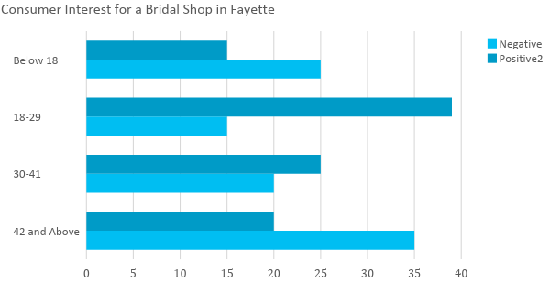

SWOT Analysis | Strengths | Weaknesses | Opportunities | Threats
[Pretty White Bridal Salon] | - One-stop shop for any bride  - Trusted expertise of Mallory Williams as a designer  - Excellent product quality and service | - A start-up business  - Still not known to the public | - The popularity of [Mallory Williams] as a wedding dress designer  - The retail fashion industry in [Fayette, Ohio ]is still growing | - Since it is still a start-up business, consumers tend to have low expectations on the business’ service and opt for their usual preference
[Queens Bridal Shop] | - The go-to bridal shop of the people of [Fayette, Ohio]  - Excellent product quality and service | - Located outside of the town, requiring people to travel about an hour or two  - Does not cater to the other needs of the bride such as shoes and undergarments | - Continuous interest and patronage of the public of the business  - Room for business expansion as a result of the public’s growing demand | - Locations of competitor bridal shops are nearer [Fayette, Ohio]
[Elegance Bridal Gallery] | - Known for its cheap bridal and entourage packages | - Quality of products/services is below average | - More people go for cheaper and less expensive products for their wedding preparation | - There are bridal shops that offer high-quality designs and services at affordable price ranges

Marketing Strategy

[Pretty White Bridal Salon] aims to utilize various media to increase the public’s awareness of the business. The business will incorporate video advertisements on various social media channels such as Facebook, Twitter, Instagram, and YouTube. Aside from that, information about the business will be printed out and advertised in wedding magazines. Posters are to be put up around town to inform the public about the business right before its scheduled opening date.

The following strategies have been started by the marketing director to achieve the business’ promotional goals:

Marketing Strategy | Activities | Timeline | Success Criteria
Video advertisements on social media platforms | - Hire a videographer or animator to create a video ad | February 20, 2018 | A video will be completed by the end of [February 2018].
Wedding magazine article/ads | - Contact known publishers of wedding magazines to include information about the business in a column or an ad space | February 12, 2018 | Schedule an interview for [Mallory Williams] by [February 20, 2018].
Posters | - Put up posters around town where consumers can easily spot them | ASAP | Final poster design will be completed on [February 10, 2018].

Organizational Structure

[Pretty White Bridal Salon] follows a simple organizational structure under the expert supervision of [Ms. Mallory G. Williams] as seen on the chart below.

Mallory Williams
OWNER
Operations Manager
Marketing Director
Designers
Finance Manager
Sales/Operations Staff
Maintenance Staff

The business is currently in the process of hiring an operation and financial manager as well as sales staff and designers. A detailed table below is provided to show the responsibilities of each position indicated above.

Name | Position | Responsibilities
[Sally Harper] | Marketing Director | To oversee the advertising and promotional activities of the business
[Barbara Paulin] | Operations Manager | To handle the day-to-day operations of the bridal shop  To control and monitor the inventory.

OPERATIONAL PLAN

Location and Facilities

[Pretty White Bridal Salon] will be situated at [3774 Davis Place Fayette, Ohio]. [Ms. Mallory Williams] leased a residential property for [2,000] USD renovated to suit the home-like ambiance of the bridal shop. Provided below is the layout of the bridal shop occupying a [1725 square foot] property.

Entrance/Exit Door
Display Area
Fitting Room
Platform
Table for Discussion
Laundry/Storage Area
Door
Racks for Dresses, Bridal Accessories, Undergarments
Female/Male Toilet Area
Seats
Seats
Signage/Poster Area

Tools and Equipment Checklist

Furniture and Fixtures | Quantity
Table | 1
Display Racks | 2 for Clothing  2 for Shoes  1 for Bridal Accessories
Software | Quantity
Inventory and Supply Database | 1
Customer Database | 1
Hardware | Quantity
Desktop Computer | 1
Laptop Computer | 2

IT Infrastructure

The following table shows the IT infrastructure of [Pretty White Bridal Salon] as of [January 2018].

Infrastructure | Existing (Y/N) | Description
Social Media | N | Currently in the process of creating accounts for the business.
Databases | Y | The business uses databases for inventory and supply control and for customer information and updates.

FINANCIAL PLAN

Assumptions

The financial plan for Pretty White Bridal Salon considers the following financial assumptions:

- All bridal packages are paid on a 50-30-20 basis to cover up for the design process of the wedding dresses. Unpaid balances are recorded as the business’ receivables.

- The tax rate is [25]% of the total salary and compensation. The current market interest rate is [5]%.

- Variable expenses are expected to have a [2]% increase in the next two years due to inflation.

Monthly Expense

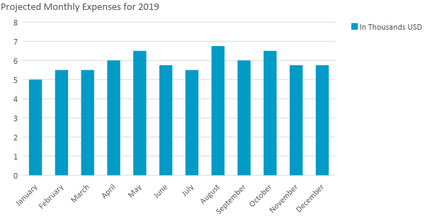

Monthly Revenue

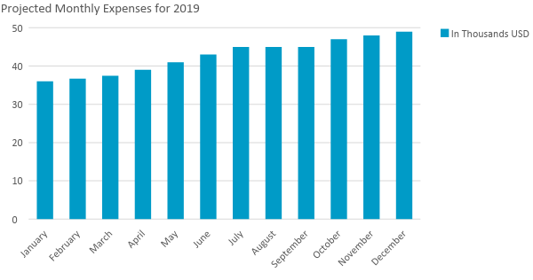

Business Financing

The initial funding to start the business comes from a business loan worth $[100,000.00]. About [60]% of the loan will cover the major expenses such as insurance, rent, salaries, advertising, and legal fees. The remaining [40]% will be used for other expenses necessary for the first three month-operation of [Pretty White Bridal Salon].

Statements

Profit and Loss Projection
 | FY2018 | FY2019 | FY2020
Sales | $432,000.00 | $440,640.00 | $449,452.80
Direct Cost of Sale | $172,800.00 | $180,662.40 | $202,253.76
Other Cost of Sale | $6,000.00 | $6,120.00 | $6,242.40
Total Cost of Goods Sold or COGS (Sales - Direct Cost of Sale - Other Cost of Sale) | $253,200.00 | $253,857.60 | $240,956.64
Gross Profit (Sales-Total Cost of Goods Sold) | $178,800.00 | $186,782.40 | $208,496.16
Gross Margin % (Gross Profit/Sales) | 41.39% | 42.39% | 46.39%
Operating Expenses
Rent | $24,000.00 | $24,000.00 | $24,000.00
Insurance | $4,000.00 | $4,000.00 | $4,000.00
Utilities | $15,000.00 | $15,300.00 | $15,606.00
Salary (Including Tax) | $50,000.00 | $50,000.00 | $50,000.00
Maintenance & Supplies | $5,000.00 | $5,000.00 | $5,000.00
Total Operating Expenses | $98,000.00 | $98,300.00 | $98,606.00
EBITDA (Total Cost of Sale-Total Operating Expenses) | $155,200.00 | $155,557.60 | $142,350.64
Depreciation | $10,000.00 | $10,000.00 | $10,000.00
Interest Expense | $5,000.00 | $5,000.00 | $5,000.00
Taxes Paid | $12,500.00 | $12,500.00 | $12,500.00
Net Profit (Gross Profit - Operating Expenses - Taxes - Interest) | $63,300.00 | $70,982.40 | $92,390.16

Balance Sheet Projection
 | FY2018 | FY2019 | FY2020
Cash | $120,000.00 | $185,000.00 | $290,000.27
Accounts Receivable | $110,000.00 | $107,843.14 | $105,728.57
Inventory | $50,000.00 | $45,000.00 | $40,000.00
Other Current Assets | $5,000.00 | $5,000.00 | $5,000.00
Total Current Assets | $285,000.00 | $342,843.14 | $440,728.83
Long-Term Assets | $40,000.00 | $40,000.00 | $40,000.00
Accumulated Depreciation | $10,000.00 | $10,000.00 | $10,000.00
Total Long-Term Assets (Long-Term Assets-Accumulated Depreciation) | $30,000.00 | $30,000.00 | $30,000.00
Total Assets (Total Current Assets + Total Long-Term Assets) | $315,000.00 | $372,843.14 | $470,728.83
Accounts Payable | $80,000.00 | $70,000.00 | $60,000.00
Notes Payable | $4,000.00 | $3,000.00 | $2,500.00
Other | $4,000.00 | $4,000.00 | $4,000.00
Total Liabilities | $88,000.00 | $77,000.00 | $66,500.00
Paid-in Capital | $100,000.00 | $100,000.00 | $100,000.00
Retained Earnings | $63,300.00 | $134,282.40 | $226,672.56
Total Owner's Equity (Total Assets - Total Liabilities) | $227,000.00 | $295,843.14 | $404,228.83
Total Liabilities & Equity (Total Liabilities/Total Owner's Equity) | 38.77% | 26.03% | 16.45%

Cash Flow Projection
 | FY2018 | FY2019 | FY2020
Operating Cash Beginning | $10,000.00 | $120,000.00 | $185,000.00
Sources of Cash | $10,000.00 | $5,000.00 | $5,000.27
Receivables | $50,000.00 | $30,000.00 | $40,000.00
Sales | $40,000.00 | $20,000.00 | $50,000.00
Others | $10,000.00 | $10,000.00 | $10,000.00
Total Cash | $120,000.00 | $185,000.00 | $290,000.27
Expenditures
Rent | $24,000.00 | $24,000.00 | $24,000.00
Insurance | $4,000.00 | $4,000.00 | $4,000.00
Utilities | $15,000.00 | $15,300.00 | $15,606.00
Salary (Including Tax) | $50,000.00 | $50,000.00 | $50,000.00
Maintenance & Supplies | $5,000.00 | $5,000.00 | $5,000.00
Total Expenditures | $98,000.00 | $98,300.00 | $98,606.00
Net Income/Loss (Total Cash - Total Expenditures) | $22,000.00 | $86,700.00 | $191,394.27

