90 Day MARKETING PLAN

[C3 Mobile Inc]
[2018 – 2019]

Index

Executive Summary [PAGE NUMBER]

Company Overview [PAGE NUMBER]

Products and Services [PAGE NUMBER]

Marketing Analysis [PAGE NUMBER]

Strategy and Implementation [PAGE NUMBER]

Management and Personnel [PAGE NUMBER]

Financial Plan [PAGE NUMBER]

EXECUTIVE SUMMARY

[C3 Mobile Inc] is a mid-sized mobile phone manufacturer based in [Detroit, Michigan]. The company originally manufactures call-and-text phones but, this year, it will launch a smartphone to remain competitive in the market. The company targets millennials who have been ranked as the largest purchaser of smartphones as of [2017].

[C3 Mobile Inc] will be conducting a marketing campaign for its new product within 90 days prior to the scheduled launching. In 90 days, the company will aggressively utilize the influence of social media and major broadcasting networks to effectively promote the new product.

COMPANY OVERVIEW

Mission Statement

[C3 Mobile Inc] aims to provide ease in communication with the production of innovative mobile technologies to generations of today and the future.

Philosophy

[C3 Mobile Inc] works with excellent people upholding the values of creativity, professionalism, and integrity at work.

Vision

[C3 Mobile Inc] becomes one of the leading mobile phone manufacturers in the US.

Outlook

The consumer electronics market is continuously growing, particularly in the smartphone product category. The company anticipates millennials to cover a great percentage of its product sales.

Type of Industry: Consumer Electronics Industry

Business Structure: Corporation

Ownership: Corporation, [Juan Hughes] and Board Members

Start-Up Summary

[C3 Mobile Inc] had initial operating funds amounting to [100K] USD generated by the sole proprietor. The funds covered disbursements on rent, insurance, payroll, legal fees, and advertising costs.

Start-Up Funding
Start-Up Expenses | $48,700
Start-Up Assets | $51,300
Total Funding Required | $100,000
Assets
Non-Cash Assets from Start-Up | $22,000
Cash Requirements from Start-up | $4,000
Additional Cash Raised | $7,800
Cash Balance on Starting Date | $1,000
Total Assets | $34,800
Capital
Planned Investment
Owner | $100,000
Other | $0
Additional Investment Requirement | $0
Total Planned Investment | $100,000
Loss at Start-Up (Start-Up Expenses) | -$48,700
Total Capital | $51,300
Total Capital and Liabilities | $51,300
Start-Up
Requirements
Start-Up Expenses
Rent - 6 Months | $9,000
Advertising | $2,000
Legal Fees | $1,500
Manufacturing Costs | $10,000
Insurance | $1,200
Other | $25,000
Total Start-Up Expenses | $48,700
Start-Up Assets
Cash Required | $5,000
Start-Up Inventory | $18,000
Other Current Assets | $12,800
Long-Term Assets | $15,500
Total Assets | $51,300
Total Requirements (Total Start-Up Expenses + Total Assets) | $100,000

PRODUCTS AND SERVICES

Product/Service Description

[C3 Mobile Inc] manufactures mobile phones primarily used to make calls and texts. However this year, the company will introduce a smartphone to remain competitive in the market and as a response to the call of existing [C3 Mobile] users for smartphones similar to the ones produced by the leading brands.
Value Proposition

[C3 Mobile Inc] brings convenience as well as entertainment to customers through its innovative electronic products.

Pricing Strategy

[C3 Mobile Inc] prices its products competitively to establish a secure market position.

MARKETING ANALYSIS

The consumer electronics industry is continuously growing with consumers’ attachment and reliance on electronic products in their daily routines become stronger. The need for convenient and easy access to electronic data in this modern era pushes consumers to avail of the currently popular smart electronics, particularly smartphones. Governments worldwide are increasingly supporting the digitalization of all their data and processes, which could bolster the industry more on a global context.

Market Segmentation

Within the 90-day product campaign, [C3 Mobile Inc] will target millennials who make up a large percentage of the total smartphone users. The chart below shows users of smartphones according to age groups and gender as of [2017].

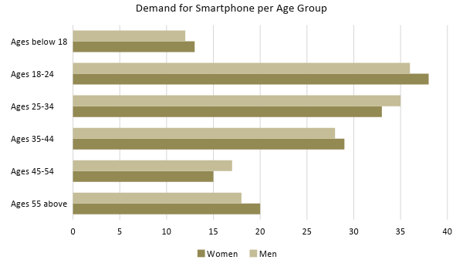

Target Market Segmentation Strategy

Consumers within the millennial age bracket

- The company will take advantage of the reach and influence of social media on this generation. [C3 Mobile Inc] will post various contents about the new product within the 90 days before the scheduled product launch.

Consumers within other age groups

- The company will use a more conventional approach to market the new product. [C3 Mobile Inc] will create a product advertisement for national televisions and must be aired on highly rated programs.

STRATEGY AND IMPLEMENTATION

Target Market Strategy

[C3 Mobile Inc] will use the following strategies to appeal to its target market during the 90-day product campaign:

- In the first 30 days, the company will post snippets of the new product’s special features on Facebook, Instagram, and Twitter that would pique the curiosity of the millennials.
- In the next 30 days, the company will post video teasers on YouTube showing pieces of the physical attributes of the new product.
- In the last 30 days, the company will advertise the scheduled product launch on major broadcasting networks and on various social media platforms.

Competitive Edge

SWOT Analysis | Strengths | Weaknesses | Opportunities | Threats
[C3 Mobile Inc] | Reputed brand for call-and-text mobile phones | A new market player when it comes to smartphones | Growth in the consumer electronics market opens opportunities for new players | Market influence of established brands
[AppleBerry Inc.] | Recognized brand worldwide for high-end smartphones | Known also for its expensive pricing | No changes in consumer preference on high-end phones regardless of price | Competitive new players that sell quality smartphones at affordable prices
[CMM Electronics Ltd.] | Ranked as the most trusted smartphone brand | Known for its products’ weak battery performance | Technological innovations that allow the company to improve the efficiency and performance of products | Consumers losing interest and trust in the company due to product inefficiency

Sales Strategy and Forecast

With the 90-day aggressive product campaign, the company targets the following monthly sales in units after the new product’s market release.

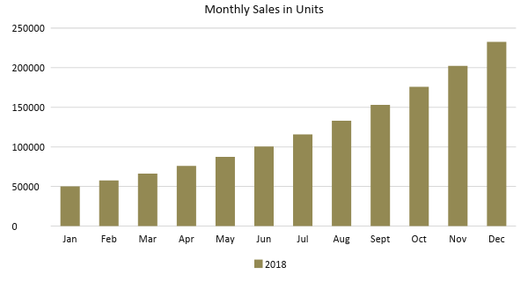

With the increasing number of smartphone users worldwide, the company anticipates the following percentage growth of smartphone purchasers among millennials.

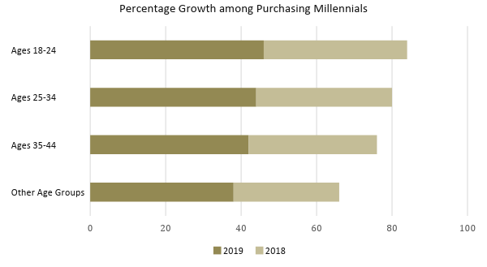
Marketing Strategy

[C3 Mobile Inc] plans to utilize the influence of both social media platforms and broadcasting networks to promote its new product within 90 days before its scheduled market introduction. The following table shows the tasks accomplished by the company to achieve the aforementioned 90-day marketing strategies.

Milestones

Marketing Strategy | Activities | Timeline | Success Criteria
Social Media Posts | Post bits and pieces of the product’s features on Facebook, Twitter, and Instagram | January 5, 2018 | The company’s posts gain multiple likes and reactions as well as comments from interested millennials.
YouTube Video Teasers | Upload video teasers of the product’s physical attributes on YouTube | February 5, 2018 | The company’s YouTube videos gain popularity during the 90-day campaign.
Visual Advertisements on Broadcasting Networks | Buy air time from major broadcasting networks for the advertisement of its new product | March 5, 2018 | Product advertisement was broadcasted nationally both on day time and primetime

MANAGEMENT AND PERSONNEL

[Juan Hughes], the chairman, along with the board members, manages and decides for the growth and development of [C3 Mobile Inc] in the consumer electronics industry. The executives of [C3 Mobile Inc] take directives from the board. The company currently employs [1,500] employees assigned in different departments.

FINANCIAL PLAN

This financial plan includes the prepared estimated break-even analysis, profit and loss, cash flows, and balance sheet of [C3 Mobile Inc].

Break-Even Analysis

Fixed Costs | Average Price | Variable Costs | Contribution Margin | Break-Even Units
$2,700.00 | $150.00 | $63.33 | $86.67 | 31
Fixed Costs | Amount |  | Variable Costs | Per Unit Amount
Rent | 1,500 |  | Advertising | 25.00
Insurance | 1,200 |  | Legal Fees | 33.33
 |  |  | Manufacturing Cost | 5.00
Total | 2,700 |  | Total | 63.33

Fixed Costs
Business Lease - Rent |  | $1,500
Insurance |  | $1,200
Total Fixed Costs |  | $2,700
Total Units Sold in 1 Month |  | 50,000
Variable Costs (Unit Sold/Cost per Unit)
Advertising | $2,000 | $25.00
Legal Fees | $1,500 | $33.33
Manufacturing Cost | $10,000 | $5.00
Total Variable Cost (Per Unit) |  | $63.33
Break-Even
Selling Price Per Unit |  | $150.00
Break-Even Point Per Unit [Fixed Costs/(Sales Price Per Unit - Variable Cost Per Unit)] |  | 2,700
 |  | 86.67
Break-Even Point in Units |  | 31
Contribution Margin (Selling Price - Total Variable Cost) |  | $86.67

Profit and Loss Projection
 | FY2018 | FY2019 | FY2020
Sales | $850,000.00 | $1,062,500.00 | $1,328,125.00
Direct Cost of Sale | $382,500.00 | $478,125.00 | $597,656.25
Other Cost of Sale | $5,000.00 | $5,000.00 | $5,000.00
Total Cost of Goods Sold or COGS (Sales - Direct Cost of Sale - Other Cost of Sale) | $462,500.00 | $579,375.00 | $725,468.75
Gross Profit (Sales-Total Cost of Goods Sold) | $387,500.00 | $483,125.00 | $602,656.25
Gross Margin % (Gross Profit/Sales) | 45.59% | 45.47% | 45.38%
Operating Expenses
Rent | $18,000.00 | $18,000.00 | $18,000.00
Insurance | $14,400.00 | $14,400.00 | $14,400.00
Utilities | $8,000.00 | $8,400.00 | $8,820.00
Salary (Including Tax) | $45,000.00 | $45,000.00 | $45,000.00
Maintenance & Supplies | $7,000.00 | $7,350.00 | $7,717.50
Total Operating Expenses | $92,400.00 | $93,150.00 | $93,937.50
EBITDA (Total Cost of Sale-Total Operating Expenses) | $370,100.00 | $486,225.00 | $631,531.25
Depreciation | $150.00 | $100.00 | $100.00
Interest Expense | $0.00 | $0.00 | $0.00
Taxes Paid | $2,250.00 | $2,250.00 | $2,250.00
Net Profit (Gross Profit - Operating Expenses - Taxes - Interest) | $292,850.00 | $387,725.00 | $506,468.75

Balance Sheet Projection
 | FY2018 | FY2019 | FY2020
Cash | $27,600.00 | $80,200.00 | $171,800.00
Accounts Receivable | $95,000.00 | $152,000.00 | $243,200.00
Inventory | $125,000.00 | $181,250.00 | $262,812.50
Other Current Assets | $55,000.00 | $79,750.00 | $115,637.50
Total Current Assets | $302,600.00 | $493,200.00 | $793,450.00
Long-Term Assets | $250,000.00 | $350,000.00 | $450,000.00
Accumulated Depreciation | $150.00 | $300.00 | $450.00
Total Long-Term Assets (Long-Term Assets-Accumulated Depreciation) | $249,850.00 | $349,700.00 | $449,550.00
Total Assets (Total Current Assets + Total Long-Term Assets) | $552,450.00 | $842,900.00 | $1,243,000.00
Accounts Payable | $50,000.00 | $47,500.00 | $45,125.00
Notes Payable | $5,000.00 | $5,250.00 | $5,512.50
Other | $3,000.00 | $3,000.00 | $3,000.00
Total Liabilities | $58,000.00 | $55,750.00 | $53,637.50
Paid-in Capital | $250,000.00 | $250,000.00 | $250,000.00
Retained Earnings | $292,850.00 | $680,575.00 | $1,187,043.75
Total Owner's Equity (Total Assets - Total Liabilities) | $494,450.00 | $787,150.00 | $1,189,362.50
Total Liabilities & Equity (Total Liabilities/Total Owner's Equity) | 11.73% | 7.08% | 4.51%

Cash Flow Projection
 | FY2018 | FY2019 | FY2020
Operating Cash Beginning | $5,000.00 | $27,600.00 | $80,200.00
Sources of Cash | $5,000.00 | $5,250.00 | $5,512.50
Receivables | $45,000.00 | $58,500.00 | $76,050.00
Sales | $55,000.00 | $71,500.00 | $92,950.00
Others | $10,000.00 | $10,500.00 | $11,025.00
Total Cash | $120,000.00 | $173,350.00 | $265,737.50
Expenditures
Rent | $18,000.00 | $18,000.00 | $18,000.00
Insurance | $14,400.00 | $14,400.00 | $14,400.00
Utilities | $8,000.00 | $8,400.00 | $8,820.00
Salary (Including Tax) | $45,000.00 | $45,000.00 | $45,000.00
Maintenance & Supplies | $7,000.00 | $7,350.00 | $7,717.50
Total Expenditures | $92,400.00 | $93,150.00 | $93,937.50
Net Income/Loss (Total Cash - Total Expenditures) | $27,600.00 | $80,200.00 | $171,800.00

