[SPECIFY THE NAME OF THE COMPANY]
[SPECIFY THE ADDRESS OF THE COMPANY]
[SPECIFY THE CONTACT NUMBER OF THE COMPANY]
[SPECIFY THE EMAIL ADDRESS OF THE COMPANY]

PREPARED FOR:

[SPECIFY THE NAME/S]

PREPARED BY:

[SPECIFY THE NAME/S]

BUDGET ANALYSIS

TABLE OF CONTENTS

INTRODUCTION  STATEMENT OF FINANCIAL POSITION  STATEMENT OF FINANCIAL PERFORMANCE  STATEMENT OF CASH FLOWS  BUDGET ANALYSIS | Page No.  Page No.  Page No.  Page No.  Page No.

INTRODUCTION

Budget is the primary tool that is used in a business for planning, tracking, and controlling the spending of the company. It is a plan for the outgoing expenses and incoming revenues for a time period.

The purpose of a budget is to be able to plan, track, and control the company’s spending, in a way that it would follow the objectives of the company, and shall not exceed with the funds of the company.

A budget analysis entails an assessment of the company’s income and expenditures.

This budget analysis covers the period between 20 [ ] to 20 [ ], and the method used is vertical analysis.

STATEMENT OF FINANCIAL POSITION

A statement of financial position is a financial statement that reports the assets, liabilities, and equity of the company.

 | 20_ |  |  | 20_
 | Budgeted | Actual | Variance | Budgeted | Actual | Variance
ASSETS
Current Assets
Cash and cash equivalents | $00,000.00 | $00,000.00 | 00.00% | $00,000.00 | $00,000.00 | 00.00%
Trade and other receivables | $00,000.00 | $00,000.00 | 00.00% | $00,000.00 | $00,000.00 | 00.00%
Real estate inventories
Prepayments and other current assets
Due from related parties
Total Current Assets
Noncurrent Assets
Trade receivables - net of current portion | $00,000.00 | $00,000.00 | 00.00% | $00,000.00 | $00,000.00 | 00.00%
Available for sale investments | $00,000.00 | $00,000.00 | 00.00% | $00,000.00 | $00,000.00 | 00.00%
Land and improvements | $00,000.00 | $00,000.00 | 00.00% | $00,000.00 | $00,000.00 | 00.00%
Investments in and advances to subsidiaries and joint ventures
Investment properties
Property and equipment
Deferred income tax assets
Pension asset
Other noncurrent assets
Total Noncurrent Assets
TOTAL ASSETS
LIABILITIES AND EQUITY
Current Liabilities | $00,000.00 | $00,000.00 | 00.00% | $00,000.00 | $00,000.00 | 00.00%
Current portion of long- term loans and notes payable | $00,000.00 | $00,000.00 | 00.00% | $00,000.00 | $00,000.00 | 00.00%
Short-term loans
Trade and other payables
Total Current Liabilities
Noncurrent Liabilities
Long-term loans and notes payable - net of current portion
Trade payables - net of current portion
Deposits and other liabilities
Pension liability
Deferred income tax liabilities
Total Noncurrent Liabilities
Total Liabilities
Equity
Capital stock | $00,000.00 | $00,000.00 | 00.00% | $00,000.00 | $00,000.00 | 00.00%
Additional paid-in capital | $00,000.00 | $00,000.00 | 00.00% | $00,000.00 | $00,000.00 | 00.00%
Unrealized valuation gain on company investments
Deposits for future stock subscriptions
Remeasurement loss on employee benefits
Retained Earnings:
Appropriated for future business expansion | $00,000.00 | $00,000.00 | 00.00% | $00,000.00 | $00,000.00 | 00.00%
Unappropriated | $00,000.00 | $00,000.00 | 00.00% | $00,000.00 | $00,000.00 | 00.00%
Total Equity
TOTAL LIABILITIES AND EQUITY

STATEMENT OF FINANCIAL PERFORMANCE

The statement of financial performance indicates the revenues of the company, as well as its expenses.

 | 20__ |  |  | 20__
 | Budgeted | Actual | Variance | Budgeted | Actual | Variance
Revenues | $000,000.00 | $000,000.00 | 100.00% | $000,000.00 | $000,000.00 | 100.00%
Cost of Real Estate Inventories Sold | $000,000.00 | $000,000.00 | 00.00% | $000,000.00 | $000,000.00 | 00.00%
Cost of Investment Property Sold
Cost of Services
Gross Profit
General and Administrative Expenses
Other Income
Interest Income
Interest Expense and other financing charges
Others
Total
Income Before Income Tax
Provision for Income Tax
Net Income

STATEMENT OF CASH FLOWS

The statement of cash flows is a financial statement which provides for the inflow and outflow of cash in the company. It is essentially divided into three: cash flows from operating activities, cash flows from investing activities, and cash flows from financing activities.

 | 20__ |  |  | 20__
 | Budgeted | Actual | Variance | Budgeted | Actual | Variance
CASH FLOWS FROM OPERATING ACTIVITIES
Income before income tax | $000,000.00 | $000,000.00 | 00.00% | $000,000.00 | $000,000.00 | 00.00%
Adjustments to reconcile income before income tax to net cash flows:
Dividend income | $000,000.00 | $000,000.00 | 00.00% | $000,000.00 | $000,000.00 | 00.00%
Depreciation and amortization | $000,000.00 | $000,000.00 | 00.00% | $000,000.00 | $000,000.00 | 00.00%
Gain on sale of investment property
Interest expense | $000,000.00 | $000,000.00 | 00.00% | $000,000.00 | $000,000.00 | 00.00%
Interest income | $000,000.00 | $000,000.00 | 00.00% | $000,000.00 | $000,000.00 | 00.00%
Net unrealized foreign exchange gain | $000,000.00 | $000,000.00 | 00.00% | $000,000.00 | $000,000.00 | 00.00%
Pension expense | $000,000.00 | $000,000.00 | 00.00% | $000,000.00 | $000,000.00 | 00.00%
Loss (Gain) on sale of property and equipment | $000,000.00 | $000,000.00 | 00.00% | $000,000.00 | $000,000.00 | 00.00%
Operating income before working capital adjustments | $000,000.00 | $000,000.00 | 00.00% | $000,000.00 | $000,000.00 | 00.00%
Decrease (Increase) in:
Trade and other receivables | $000,000.00 | $000,000.00 | 00.00% | $000,000.00 | $000,000.00 | 00.00%
Real estate inventories | $000,000.00 | $000,000.00 | 00.00% | $000,000.00 | $000,000.00 | 00.00%
Prepayments and other current assets | $000,000.00 | $000,000.00 | 00.00% | $000,000.00 | $000,000.00 | 00.00%
Increase (Decrease) in:
Trade and other payables | $000,000.00 | $000,000.00 | 00.00% | $000,000.00 | $000,000.00 | 00.00%
Pension liability
Deposits and other liabilities | $000,000.00 | $000,000.00 | 00.00% | $000,000.00 | $000,000.00 | 00.00%
Net cash generated from operations | $000,000.00 | $000,000.00 | 00.00% | $000,000.00 | $000,000.00 | 00.00%
Income tax paid | $000,000.00 | $000,000.00 | 00.00% | $000,000.00 | $000,000.00 | 00.00%
Contributions to retirement fund | $000,000.00 | $000,000.00 | 00.00% | $000,000.00 | $000,000.00 | 00.00%
Net cash flows from operating activities | $000,000.00 | $000,000.00 | 00.00% | $000,000.00 | $000,000.00 | 00.00%
CASH FLOWS FROM INVESTING ACTIVITIES
Additions to:
Land and improvements | $000,000.00 | $000,000.00 | 00.00% | $000,000.00 | $000,000.00 | 00.00%
Investments and advances to subsidiaries | $000,000.00 | $000,000.00 | 00.00% | $000,000.00 | $000,000.00 | 00.00%
Property and equipment | $000,000.00 | $000,000.00 | 00.00% | $000,000.00 | $000,000.00 | 00.00%
Investment properties | $000,000.00 | $000,000.00 | 00.00% | $000,000.00 | $000,000.00 | 00.00%
Dividends received | $000,000.00 | $000,000.00 | 00.00% | $000,000.00 | $000,000.00 | 00.00%
Interest received | $000,000.00 | $000,000.00 | 00.00% | $000,000.00 | $000,000.00 | 00.00%
Proceeds from sale of investment property
Decrease (Increase) in:
Other noncurrent assets | $000,000.00 | $000,000.00 | 00.00% | $000,000.00 | $000,000.00 | 00.00%
Advances to subsidiaries | $000,000.00 | $000,000.00 | 00.00% | $000,000.00 | $000,000.00 | 00.00%
Due from related parties | $000,000.00 | $000,000.00 | 00.00% | $000,000.00 | $000,000.00 | 00.00%
Increase (Decrease) in:
Trade payables net of current portion | $000,000.00 | $000,000.00 | 00.00% | $000,000.00 | $000,000.00 | 00.00%
Retention Payables | $000,000.00 | $000,000.00 | 00.00% | $000,000.00 | $000,000.00 | 00.00%
Proceeds from sale of property and equipment | $000,000.00 | $000,000.00 | 00.00% | $000,000.00 | $000,000.00 | 00.00%
Net cash flows used in investing activities | $000,000.00 | $000,000.00 | 00.00% | $000,000.00 | $000,000.00 | 00.00%
CASH FLOWS FROM FINANCING ACTIVITIES
Payments of:
Long-term loans | $000,000.00 | $000,000.00 | 00.00% | $000,000.00 | $000,000.00 | 00.00%
Short-term loans | $000,000.00 | $000,000.00 | 00.00% | $000,000.00 | $000,000.00 | 00.00%
Cash dividends | $000,000.00 | $000,000.00 | 00.00% | $000,000.00 | $000,000.00 | 00.00%
Interest | $000,000.00 | $000,000.00 | 00.00% | $000,000.00 | $000,000.00 | 00.00%
Proceeds from short-term loans | $000,000.00 | $000,000.00 | 00.00% | $000,000.00 | $000,000.00 | 00.00%
Proceeds from additional stock subscription | $000,000.00 | $000,000.00 | 00.00% | $000,000.00 | $000,000.00 | 00.00%
Net cash flows used in financing activities | $000,000.00 | $000,000.00 | 00.00% | $000,000.00 | $000,000.00 | 00.00%
NET DECREASE IN CASH AND CASH EQUIVALENTS | $000,000.00 | $000,000.00 | 00.00% | $000,000.00 | $000,000.00 | 00.00%
EFFECT OF EXCHANGE RATE CHANGES ON CASH AND CASH EQUIVALENTS | $000,000.00 | $000,000.00 | 00.00% | $000,000.00 | $000,000.00 | 00.00%
CASH AND CASH EQUIVALENTS AT BEGINNING OF YEAR | $000,000.00 | $000,000.00 | 00.00% | $000,000.00 | $000,000.00 | 00.00%
CASH AND CASH EQUIVALENTS AT END OF YEAR | $000,000.00 | $000,000.00 | 00.00% | $000,000.00 | $000,000.00 | 00.00%

BUDGET ANALYSIS

- Statement of Financial Position

First Year:

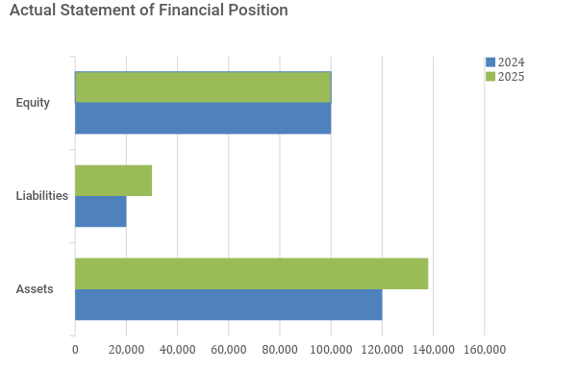

Second Year:

With respect to the difference between the 2 periods:

Budgeted:

Actual:

As provided above, the budget is [SPECIFY PERCENTAGE OF ACCURACY] accurate.

Interpretation: [SPECIFY INTERPRETATION]

Areas for improvement in budget preparation: [SPECIFY AREAS FOR IMPROVEMENT]

- Statement of Financial Performance

First Year:

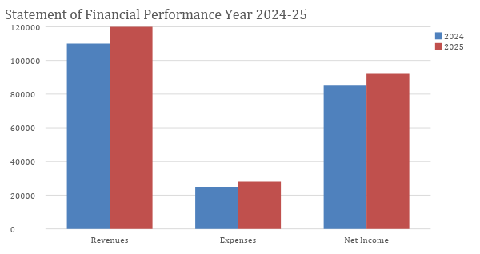

Second Year:

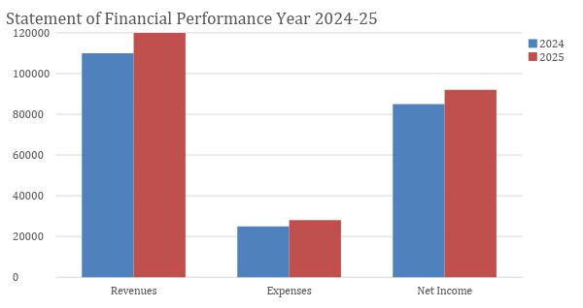

Budgeted:

Actual:

As provided above, the budget is [SPECIFY PERCENTAGE OF ACCURACY] accurate.

Interpretation: [SPECIFY INTERPRETATION]

Areas for improvement in budget preparation: [SPECIFY AREAS OF IMPROVEMENT]
- Statement of Cash Flows

First Year:
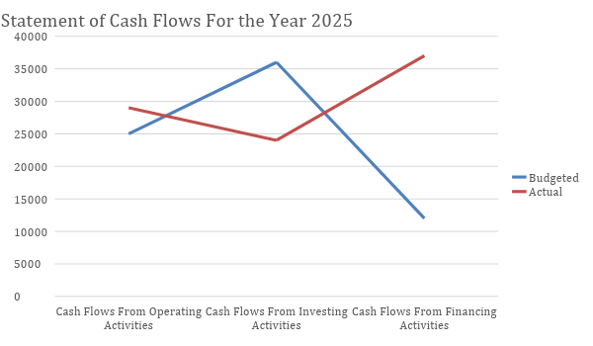

Second Year:

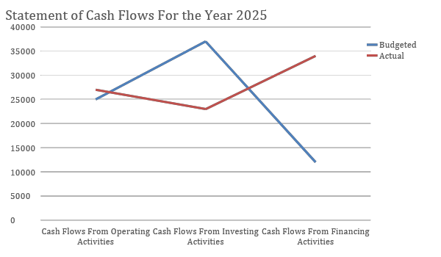

Budgeted:

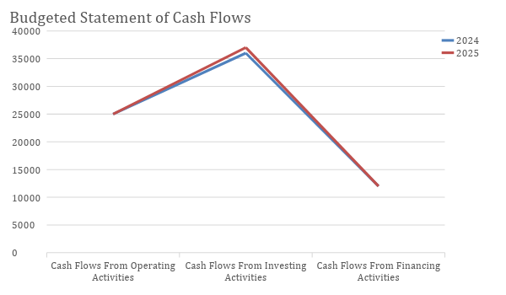

Actual:

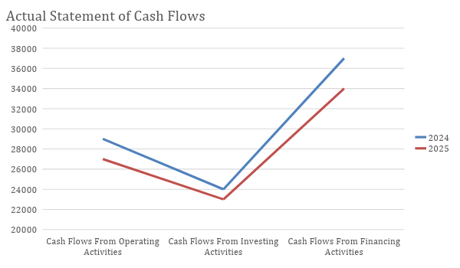

As provided above, the budget is [SPECIFY PERCENTAGE OF ACCURACY] accurate.

Interpretation: [SPECIFY INTERPRETATION]

Areas for improvement in budget preparation: [SPECIFY AREAS OF IMPROVEMENT]

