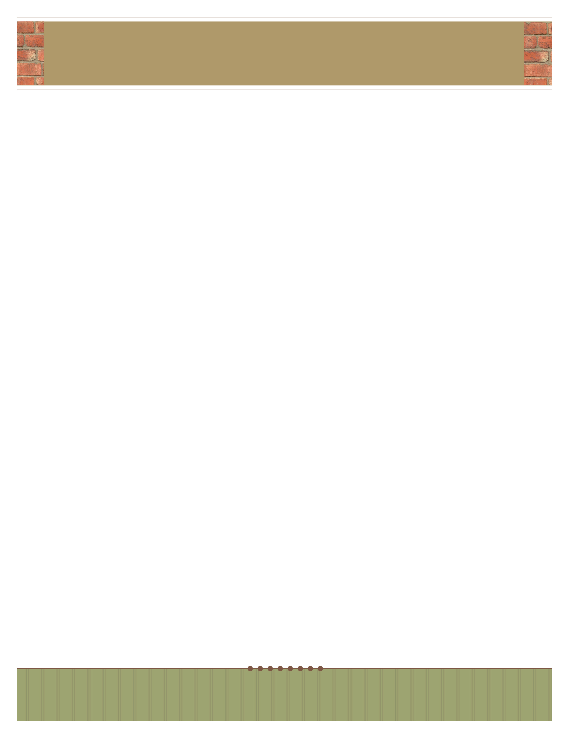
your name here
your title here

Begin your letter here.

telephone: 555.555.5555 | facsimile: 555.555.5555 | email: yourmail@email.com
address: 5555 Street Address | City, State 55555

website: www.webaddress.com

