LOTTERY BUSINESS PLAN

[INSERT NAME OF THE BUSINESS/COMPANY]
[INSERT THE COMPLETE BUSINESS/COMPANY ADDRESS]
[INSERT THE BUSINESS/COMPANY CONTACT NUMBERS]
[INSERT THE BUSINESS/COMPANY EMAIL ADDRESS]
[INSERT THE BUSINESS/COMPANY WEBSITE ADDRESS]

PREPARED BY:

[INSERT FULL NAME/S OF THE
PEOPLE WHO PREPARED THIS PLAN]

[INSERT DATE]

Index

Executive Summary [PAGE NUMBER]
Company Overview [PAGE NUMBER]
Products and Services [PAGE NUMBER]
Execution [PAGE NUMBER]
Operational Plan [PAGE NUMBER]
Financial Plan [PAGE NUMBER]

EXECUTIVE SUMMARY:

[EZPot Mini Lotto] is a [small-scale lottery] in [Massachusetts]. Currently operating [15 outlets] around the state, the company aims to attract the working millennials by making it convenient for them to buy tickets using a mobile application and or through a website. A significant increase in revenue is seen with this move to go digital.

COMPANY OVERVIEW:

Mission Statement: [EZPot Mini Lotto] provides an exciting gaming platform for lottery players in [Massachusetts].

Philosophy: [Honesty and transparency] are central in responsible [gambling]. [EZPot Mini Lotto] conducts its business with the utmost care, privacy, and confidence, assuring each player that there is no cheating in the games' internal systems.

Vision: [EZPot Mini Lotto] envisions to be a viable alternative lottery game for low-betting players in Massachusetts.

Outlook: The lottery industry in the [US] is seen to grow by [8%] within the next decade as there are no signs of a significant decrease in sales. In Massachusetts, the annual average spending for the lottery is [$734.85], which indicates that the company is guaranteed a net income even when the competitors are doing good as well. This is despite the fact that more than 56% of the population are also resorting to small-scale lotteries with lower stakes and cheaper tickets.

Type of Industry: [Gambling Industry]

Business Structure: [Limited Liability Company] (LLC)

Ownership: [James J. Brennan], [Blake R. Mason], Matilda [S. Lime - Members/Operators]

Start-Up Summary: The [$100,000.00] startup expenses include permits and [licenses, insurance, and IT systems development and maintenance].

Start-Up Funding
Start-Up Expenses | $50,000.00
Start-Up Assets | $50,000.00
Total Funding Required | $100,000.00
Assets
Non-Cash Assets from Start-Up | $10,000.00
Cash Requirements from Start-up | $30,000.00
Additional Cash Raised | $0.00
Cash Balance on Starting Date | $10,000.00
Total Assets | $50,000.00
Capital
Planned Investment
Owners | $90,000.00
Additional Investment Requirement | $10,000.00
Total Planned Investment | $100,000.00
Loss at Start-Up (Start-Up Expenses) | -$50,000.00
Total Capital | $50,000.00
Total Capital and Liabilities | $50,000.00
Start-Up
Requirements
Start-Up Expenses
Rent and Utilities | $10,000.00
IT Systems & Maintenance | $18,000.00
Insurance | $15,000.00
Permits & Licenses | $2,000.00
Marketing and Promotion | $5,000.00
Total Start-Up Expenses | $50,000.00
Start-Up Assets
Cash Required | $40,000.00
Other Current Assets | $5,000.00
Long-Term Assets | $5,000.00
Total Assets | $50,000.00
Total Requirements (Total Start-Up Expenses + Total Assets) | $100,000.00

MANAGEMENT TEAM:

Management Team | Role/Function | Skills
James J. Brennan | Chief Executive Officer | Communication, organization, conflict management
Blake R. Mason | Chief Operations Officer | Resource management, systems development, time management
Matilda S. Lime | IT Management Director | Systems analysis, troubleshooting, technical
Joan L. Cunanan | Finance Officer | Accounting, finance management and reporting, analytical

SHORT- AND LONG-TERM GOALS AND MILESTONES:

Short-Term Goals | Milestones
Build official betting website | - Hired systems developer and gaming consultant (September 17, 2018)  - Beta tested the website (November 19, 2018)
Acquire business permit and license to operate | - Completed requirements for nationwide lottery operations (November 17, 2018)  - Requested list of requirements for international operations license (October 17, 2018)
Long-Term Goals | Milestones
Secure payment gateway solutions provider | - Signed contract with provider (December 23, 2018)
Increase revenue sources | - Created a three-year sales and marketing plan (December 17, 2018)

PRODUCTS AND SERVICES

Product/Service Description: [EZPot Mini Lotto] offers [scratchcards], draw-based and Keno-type lottery games. Being a mini lottery, a customer can only win as much [$100,000.00]. The company plans to extend its services digitally by developing a website and a mobile application where players all around Massachusetts can easily make and pay for their bets.

Value Proposition: [EZPot Mini Lotto] positions itself as the cheaper alternative lottery game, intended most especially for beginners and millennial players living under a budget.

Pricing Strategy: All tickets are sold cheaper than the average [$2.00] national lottery tickets. By utilizing dive pricing, the business will be able to achieve higher sales despite lower prices since there is an increase in the number of players betting on low-stakes lottery games.

EXECUTION

Marketing Plan: [EZPot Mini Lotto] aims to capture the online betting market of [Massachusetts]. The company will offer a gambling platform for both website and mobile application users. Key features of the app and website include customer experience optimization and data security.

Market Research: The market for mini lottery games consists of employed millennials and new players in the [23 to 35] age range. A recent market survey reveals that online mini lotteries have huge market potential because they offer more chances of winning for any registered player. Young gamblers find entertainment and financial value in a [low-stakes lottery] as it presents lower risks on their part.

SWOT Analysis | Strengths | Weaknesses | Opportunities | Threats
EZPot Mini Lotto | Affordability | Internal management issues | Growing demand for digitized mini lotto | Data security breach
Massachusetts State Lottery | Offering biggest prizes among statewide lotteries | Expensive ticket prices | Options to bet include text messaging | Bigger tax cuts on jackpot prizes
Gambler's World | Huge customer base | Poor marketing strategies | New IT updates for increased website protection | Hacks into online payment systems

Marketing Strategy: [EZPot Mini Lotto] brands itself as the company offering the best and cheapest mini lottery games in the whole Massachusetts area. In order to reach its target market of young players, [EZPot Mini Lotto] will provide digital alternatives where they can log in and make their bets without having to go to a physical retailer.

Marketing Strategy | Activities | Timeline | Success Criteria
Social media | Build Twitter and Facebook accounts | October 2018 | 15% increase in Facebook likes and Twitter following three months after the accounts were created
Customer experience optimization | Place customer-centric features such as player sign-ins, FAQ portal, etc. on website and mobile app | November 2018 to present | Increase in number of visits and registered users

ORGANIZATIONAL STRUCTURE:

CEO
BOARD OF DIRECTORS
COO
FINANCE
IT
MARKETING

OPERATIONAL PLAN:

Location and Facilities: [EZPot Mini Lotto] operates at a rented office space in [165] Wiseman Street. Interior facilities include stations for the directors and staff, an IT room, a comfort room, and a pantry.

Tools and Equipment Checklist:

Software | Quantity
CStorePro lottery management software | 1
Xero accounting software | 1
Hardware | Quantity
PC units | 5
Whiteboard | 2

IT Infrastructure

Infrastructure | Existing (Y/N) | Description
Website | Y | - Undergoing test runs  - Includes player account management, geoblocking, and customer contact portal capabilities
Social media | Y | - Used to promote the lottery and release to the public the daily lotto results

FINANCIAL PLAN

Assumptions: The financial plan for [EZPot Mini Lotto] is based on the following assumptions:

1. Monthly total expenses will not exceed [$5,000.00].

2. Monthly revenue growth rate at [3.5%].

Monthly Expense

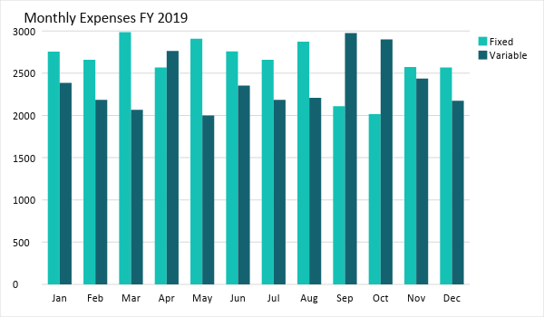

Monthly Revenue

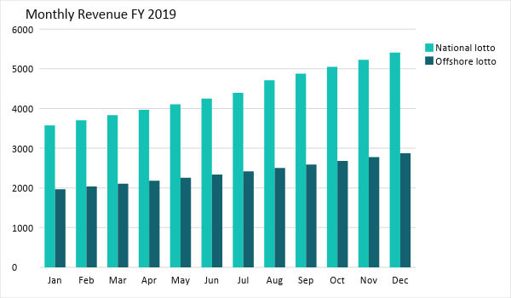

BUSINESS FINANCING

The business will be funded by the members. All expenses beginning in [FY 2020] will be paid for by
business income.

STATEMENTS

Profit and Loss Projection
 | FY2019 | FY2020
Sales | $81,843.61 | $114,201.05
Direct Cost of Sale | $20,460.90 | $39,756.37
Other Cost of Sale | $1,750.89 | $2,986.87
Total Cost of Goods Sold or COGS (Sales - Direct Cost of Sale - Other Cost of Sale) | $22,211.79 | $42,743.24
Gross Profit (Sales-Total Cost of Goods Sold) | $59,631.82 | $71,457.81
Gross Margin % (Gross Profit/Sales) | 72.86% | 62.57%
Operating Expenses
Rent and Utilities | $10,000.00 | $12,000.00
IT Systems & Maintenance | $18,000.00 | $20,000.00
Insurance | $15,000.00 | $15,000.00
Permits & Licenses | $2,000.00 | $1,000.00
Marketing and Promotion | $5,000.00 | $7,000.00
Total Operating Expenses | $50,000.00 | $55,000.00
EBITDA (Total Cost of Sale-Total Operating Expenses) | -$27,788.21 | -$12,256.76
Depreciation | $0.00 | $0.00
Interest Expense | $3,000.00 | $5,000.00
Taxes Paid | $2,000.00 | $3,000.00
Net Profit (Gross Profit - Operating Expenses - Taxes - Interest) | $4,631.82 | $8,457.81

Balance Sheet Projection
 | FY2019 | FY2020
Cash | $40,000.00 | $40,000.00
Accounts Receivable | $0.00 | $2,000.00
Inventory | $0.00 | $0.00
Other Current Assets | $5,000.00 | $7,000.00
Total Current Assets | $45,000.00 | $49,000.00
Long-Term Assets | $5,000.00 | $7,000.00
Accumulated Depreciation | $0.00 | $1,000.00
Total Long-Term Assets (Long-Term Assets-Accumulated Depreciation) | $5,000.00 | $6,000.00
Total Assets (Total Current Assets + Total Long-Term Assets) | $50,000.00 | $55,000.00
Accounts Payable | $0.00 | $1,000.00
Notes Payable | $0.00 | $1,000.00
Other | $1,000.00 | $2,000.00
Total Liabilities | $1,000.00 | $4,000.00
Paid-in Capital | $90,000.00 | $90,000.00
Retained Earnings | $45,000.00 | $65,000.00
Total Owner's Equity (Total Assets - Total Liabilities) | $49,000.00 | $51,000.00
Total Liabilities & Equity (Total Liabilities/Total Owner's Equity) | 2.04% | 7.84%

Cash Flow Projection
 | FY2019 | FY2020
Operating Cash Beginning | $40,000.00 | $40,000.00
Sources of Cash
Receivables | $0.00 | $2,000.00
Sales | $81,843.61 | $114,201.05
Others | $5,000.00 | $7,000.00
Total Cash | $126,843.61 | $163,201.05
Expenditures
Rent and Utilities | $10,000.00 | $12,000.00
IT Systems & Maintenance | $18,000.00 | $20,000.00
Insurance | $15,000.00 | $15,000.00
Permits & Licenses | $2,000.00 | $1,000.00
Marketing and Promotion | $5,000.00 | $7,000.00
Total Expenditures | $50,000.00 | $55,000.00
Net Income/Loss (Total Cash - Total Expenditures) | $76,843.61 | $108,201.05

