PARKING OR VALET PARKING BUSINESS PLAN
[INSERT COMPANY NAME]
Business Plan for Fiscal Year [INSERT YEAR]
[INSERT DATE]

[John Knowles]
[johnknowles@gmail.com]
[702-730-5836]
[www.thepremiumvalet.com]
[3811 West Charleston Boulevard]
[Rancho Oakey, Las Vegas, NV 89102, USA]
INDEX

EXECUTIVE SUMMARY  COMPANY OVERVIEW  PRODUCTS AND SERVICES  EXECUTION  OPERATIONAL PLAN  FINANCIAL PLAN | [INSERT PAGE NO.]  [INSERT PAGE NO.]  [INSERT PAGE NO.]  [INSERT PAGE NO.]  [INSERT PAGE NO.]  [INSERT PAGE NO.]

EXECUTIVE SUMMARY

The [Premium Valet] is a valet parking service provider in [Las Vegas, Nevada]. The company considers hotels, shopping malls, and casinos as its target market. To effectively promote the company, aside from owning a website, it will also utilize social media and email marketing to attract and gain more customers.

The company plans to become a major parking service provider during conventions and expositions in the coming years.

COMPANY OVERVIEW

Mission Statement: The [Premium Valet] provides reliable and excellent valet parking services to guests of luxurious commercial establishments in [Las Vegas, Nevada].

Philosophy: The employees of The [Premium Valet] upholds the values of professionalism, respect, and integrity to ensure customer satisfaction.

Vision: The [Premium Valet] becomes the premier in valet parking and parking management in [Las Vegas, Nevada].

Outlook: The increasing number of car owners in [Las Vegas, Nevada], establishes a continuous demand for valet parking services in establishments such as hotels, shopping complexes, and casinos. In this regard, the company expects increments in the number of clients in the aforementioned categories.

Type of Industry: Service Industry

Business Structure: Sole Proprietorship

Ownership: Sole Proprietorship, [John Knowles]

Start-Up Summary: The sole proprietor generated [130K] USD to initially fund the operation of The Premium Valet. The fund generated covers startup disbursements such as rent, insurance, payroll, legal fees, and staff training.

Start-Up Funding
Start-Up Expenses | $70,460
Start-Up Assets | $59,540
Total Funding Required | $130,000
Assets
Non-Cash Assets from Start-Up | $35,500
Cash Requirements from Start-up | $7,000
Additional Cash Raised | $15,500
Cash Balance on Starting Date | $1,540
Total Assets | $59,540
Capital
Planned Investment
Owners | $130,000
Other | $0
Additional Investment Requirement | $0
Total Planned Investment | $130,000
Loss at Start-Up (Start-Up Expenses) | -$70,460
Total Capital | $59,540
Liabilities | $0
Total Capital and Liabilities | $59,540
Start-Up
Requirements
Start-Up Expenses
Rent - 6 Months | $8,460
Advertising | $2,500
Legal Fees | $1,500
Staff Training | $6,500
Insurance | $1,500
Other | $50,000
Total Start-Up Expenses | $70,460
Start-Up Assets
Cash Required | $8,540
Start-Up Inventory | $10,000
Other Current Assets | $15,500
Long-Term Assets | $25,500
Total Assets | $59,540
Total Requirements (Total Start-Up Expenses + Total Assets) | $130,000

Management Team:

Management Team | Role/Function | Skills
John Knowles | General Manager | Leadership, Communication, Team Management, Decision-Making
Vincent Peters | HR Manager | Employee Relations, Communication

Short- and Long-Term Goals and Milestones:

Short-Term Goals | Milestones
Hire a sales and marketing manager | Employed a qualified applicant last October 20, 2018
Recruit qualified valet parking attendants | Provided job offers to 5 more valet parking attendants
Long-Term Goals | Milestones
Provide valet parking services to conventions and expositions | Started email marketing to potential clients
Establish a market base in Las Vegas, Nevada | Opened a Facebook account to promote its services

PRODUCTS AND SERVICES

Product/Service Description: The [Premium Valet] partners with hotels, shopping malls, and casinos in providing premium quality valet parking services to their guests.

Value Proposition: The [Premium Valet] takes great care in handling the cars of guests when parking them. All parking attendants undergo strict training in order for the company to deliver excellent services.

Pricing Strategy: The [Premium Valet] charges its partners a set fee of [$100] per day for the valet parking services rendered. The company uses the competitive pricing approach as its pricing strategy.

EXECUTION

Marketing Plan: Aside from the website, The [Premium Valet] also plans to use both social media and email marketing strategies to promote its services.

Market Research: There is projected growth in the parking management market with the increasing number of car owners in the US. A recent market survey of the company in [Las Vegas, Nevada], yielded the following results:

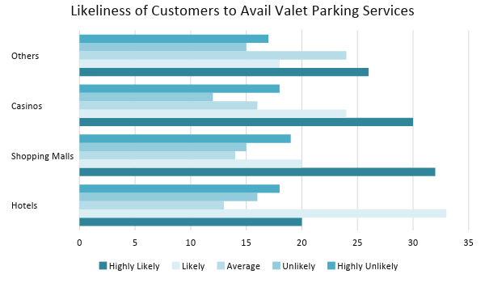

SWOT Analysis | Strengths | Weaknesses | Opportunities | Threats
The  Premium Valet | Provides efficient valet parking services | Weak market presence | Large establishments tend to choose companies that offer affordable yet excellent quality valet parking services | Influence of established valet parking service companies in Las Vegas, Nevada
At Your Valet Service | Holds a record of being the top choice of hotels and resorts | High employee turnover | Clients stick to their usual service providers, especially if the company is a reliable one | Emerging companies having high efficiency and low employee turnover
The Parking Managers | Uses innovative ways to render valet parking and parking management at casinos | Targets only the elite class | Consumer purchasing power is gradually increasing which means that there will be more car owners going to casinos | Valet parking services that are open to provide its services to any kind of establishment

Marketing Strategy: The [Premium Valet] will use social media platforms to advertise its services to a wider market. The company will also send emails to target establishments that it recognizes as potential clients.

Marketing Strategy | Activities | Timeline | Success Criteria
Social Media Marketing | Post information about the company’s services along with the website link | ASAP | The company’s website gains 1,000 visits from customers by January 2019.
Email Marketing | Send subscription/  newsletter emails to potential and existing clients | January 1, 2019 | The company obtains 20 new clients by the end of January 2019.
-- | -- | -- | --

Organizational Structure:

The [Premium Valet] follows a simple organizational structure with the general manager, John Knowles, at the top. The general manager decides on the strategies that the company will take in order to grow. The HR and sales and marketing managers submit reports to the general manager as his guide to make important decisions. The general manager also assumes the responsibility of being an operations manager. He supervises and evaluates the performance of the valet attendants.

OPERATIONAL PLAN

Location and Facilities

The [Premium Valet] occupies a [940 square foot] office space in [3811 West Charleston Boulevard Rancho Oakey, Las Vegas, NV 89102, USA]. The company has an open-office layout for ease of communication between employees.

Tools and Equipment Checklist

Software | Quantity
Accounting Software | 1
Payroll System | 1
Hardware | Quantity
Computers | 4
Printers | 2

IT Infrastructure

The Premium Valet uses the following IT infrastructure in its operations.

Infrastructure | Existing (Y/N) | Description
Social Media | Y | The company has a Facebook account.
Latency | Y | The company experiences quick processing and response time.
Downtime | N | The company does not encounter disruptions when using its chosen network.
-- | -- | --

FINANCIAL PLAN

Assumptions

The [Premium Valet] refers to both market trends and past financial performance to create estimated financial statements. Its financial goals and objectives are based on the following assumptions:

- The company foresees an increase of 38% in sales beginning the second year of its operations.
- The prevailing market interest is [3.8%]. Compensation tax equals [11%] of the total gross compensation amount.
- There are no expected increases in expenses in the next [18 months].

Monthly Expense

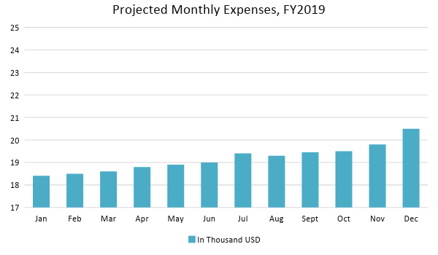

Monthly Revenue

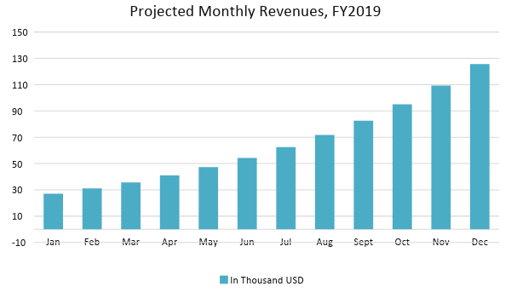

Business Financing

The [Premium Valet] generated its funds through a business loan acquired by the sole proprietor. The business loan is payable within [18 months].
Statements

Profit and Loss Projection
 | FY2019 | FY2020 | FY2021
Sales | $200,000.00 | $276,000.00 | $380,880.00
Direct Cost of Sale | $80,000.00 | $110,400.00 | $152,352.00
Other Cost of Sale | $1,500.00 | $1,575.00 | $1,653.75
Total Cost of Goods Sold or COGS (Sales - Direct Cost of Sale - Other Cost of Sale) | $118,500.00 | $164,025.00 | $226,874.25
Gross Profit (Sales-Total Cost of Goods Sold) | $81,500.00 | $111,975.00 | $154,005.75
Gross Margin % (Gross Profit/Sales) | 40.75% | 40.57% | 40.43%
Operating Expenses
Rent | $16,920.00 | $16,920.00 | $16,920.00
Insurance | $3,500.00 | $3,500.00 | $3,500.00
Utilities | $2,500.00 | $2,550.00 | $2,601.00
Salary (Including Tax) | $40,000.00 | $40,000.00 | $40,000.00
Maintenance & Supplies | $2,500.00 | $2,562.50 | $2,626.56
Total Operating Expenses | $65,420.00 | $65,532.50 | $65,647.56
EBITDA (Total Cost of Sale-Total Operating Expenses) | $53,080.00 | $98,492.50 | $161,226.69
Depreciation | $750.00 | $750.00 | $750.00
Interest Expense | $4,940.00 | $4,940.00 | $4,940.00
Taxes Paid | $4,400.00 | $4,400.00 | $4,400.00
Net Profit (Gross Profit - Operating Expenses - Taxes - Interest) | $6,740.00 | $37,102.50 | $79,018.19

Balance Sheet Projection
 | FY2019 | FY2020 | FY2021
Cash | $13,120.00 | $43,177.50 | $108,199.64
Accounts Receivable | $18,000.00 | $24,840.00 | $34,279.20
Inventory | $25,000.00 | $26,250.00 | $27,562.50
Other Current Assets | $40,000.00 | $42,000.00 | $42,000.00
Total Current Assets | $96,120.00 | $136,267.50 | $212,041.34
Long-Term Assets | $70,000.00 | $70,000.00 | $70,000.00
Accumulated Depreciation | $750.00 | $1,500.00 | $2,250.00
Total Long-Term Assets (Long-Term Assets-Accumulated Depreciation) | $69,250.00 | $68,500.00 | $67,750.00
Total Assets (Total Current Assets + Total Long-Term Assets) | $165,370.00 | $204,767.50 | $279,791.34
Accounts Payable | $15,000.00 | $10,000.00 | $5,000.00
Notes Payable | $10,000.00 | $11,500.00 | $13,225.00
Other | $3,000.00 | $3,000.00 | $3,000.00
Total Liabilities | $28,000.00 | $24,500.00 | $21,225.00
Paid-in Capital | $130,000.00 | $130,000.00 | $130,000.00
Retained Earnings | $6,740.00 | $43,842.50 | $122,860.69
Total Owner's Equity (Total Assets - Total Liabilities) | $137,370.00 | $180,267.50 | $258,566.34
Total Liabilities & Equity (Total Liabilities/Total Owner's Equity) | 20.38% | 13.59% | 8.21%

Cash Flow Projection
 | FY2019 | FY2020 | FY2021
Operating Cash Beginning | $8,540.00 | $13,120.00 | $43,177.50
Sources of Cash | $5,000.00 | $6,250.00 | $7,812.50
Receivables | $18,000.00 | $24,840.00 | $34,279.20
Sales | $45,000.00 | $62,100.00 | $85,698.00
Others | $2,000.00 | $2,400.00 | $2,880.00
Total Cash | $78,540.00 | $108,710.00 | $173,847.20
Expenditures
Rent | $16,920.00 | $16,920.00 | $16,920.00
Insurance | $3,500.00 | $3,500.00 | $3,500.00
Utilities | $2,500.00 | $2,550.00 | $2,601.00
Salary (Including Tax) | $40,000.00 | $40,000.00 | $40,000.00
Maintenance & Supplies | $2,500.00 | $2,562.50 | $2,626.56
Total Expenditures | $65,420.00 | $65,532.50 | $65,647.56
Net Income/Loss (Total Cash - Total Expenditures) | $13,120.00 | $43,177.50 | $108,199.64

